|  |
| --- |
| **Aerosol Jet™ printing insights and its technological applications**  Akash VERMA  Supervisor:  Prof. Eleonora Ferraris  Members of the Examination Committee:  Prof. Maria Rosaria Vetrano  Prof. Dominiek Reynaerts  Dr. Fernando Cortes Salazar  Prof. Wim Deferme  Prof. Tegoeh Tjahjowidodo (secretary)  Prof. Lise Appels (chair)  Dissertation presented in partial fulfilment of the requirements for the degree of Doctor of Engineering Technology  May 2023 |

© 2023 AKASH VERMA

Uitgegeven in eigen beheer, AKASH VERMA, LEUVEN, BELGIUM.

Alle rechten voorbehouden. Niets uit deze uitgave mag worden vermenigvuldigd en/of openbaar gemaakt worden door middel van druk, fotokopie, microfilm, elektronisch of op welke andere wijze ook zonder voorafgaandelijke schriftelijke toestemming van de uitgever.

All rights reserved. No part of the publication may be reproduced in any form by print, photoprint, microfilm, electronic or any other means without written permission from the publisher.

**Printed Electronics (PE) as an enabling technology to realize flexible mass customized smart applications**

Printed Electronics (PE) involves additive deposition of functional materials on a substrate via printing processes to realize electronic circuits, interconnects, electrical components or devices. This methodology is opposite to the conventional microelectronics industry which is based on subtractive manufacturing techniques (e.g. etching). Some of the advantages of PE over conventional electronics are low prototyping costs, short time to market, less processing steps, etc. One of the features is the ability to manufacture flexible and customized products and devices. The applications of Printed Electronics apply to different sectors of industry like electronics, packaging, bio-medical, automotive, communication, etc. In this work, we present Aerosol Jet® Printing (AJ®P) and Screen Printing as two techniques for the realization of flexible and mass customized PE devices. Whereas the use of AJ®P is focused on rapid prototyping, Screen Printing allows to upscale for mass production. The two technologies are here implemented to realise conductive antennas on paper substrates, potentially to integrate into a delivery parcel box for the development of “smart packaging”. This antenna design is based on the 13.56 MHz working frequency, which lies in the frequency spectrum of HF RFID/NFC applications. The print quality, electrical resistance and the basic functional characterization (working frequency) of these paper-based antennas are here investigated and reported.

1. Introduction

Printed Electronics (PE) is a production technological area which allows to deposit different types of materials on a wide range of substrates by various printing techniques. The purpose is to manufacture state-of-the-art electronic devices. It is not only restricted to printing and electronics, but it is a multi-disciplinary domain, an amalgamation of material science, physics, chemistry, wireless communication, reliability engineering, fractural mechanics, and many more [1]. It is one of the most emerging technologies rising up these days [2]. According to the IDTechEx report in 2019, the market value of the whole industry will be more than 30 Billion US $ by 2020 and expected to increase in the upcoming decade. The requirements of PE are a substrate, an ink, a printing technique and a sintering process in the end to create a fully printed device (figure 1). PE techniques are broadly divided in two categories, i.e. mask-based and mask-less printing. Some of the examples of mask-based are Screen Printing (SP), flexographic printing, gravure printing, etc. [1].

They require a stencil, a mask or a screen to deposit and transfer the ink onto a substrate in a desired pattern. Aerosol Jet® Printing (AJ®P) and inkjet printing, instead, are examples of mask-less techniques. They are also known as direct–writing techniques because indeed they do not require a mask or a stencil to print the desired pattern. These printing techniques are based on a digital platform which transforms a digital image or a computer-aided design into a print pattern [1], [3]. Some 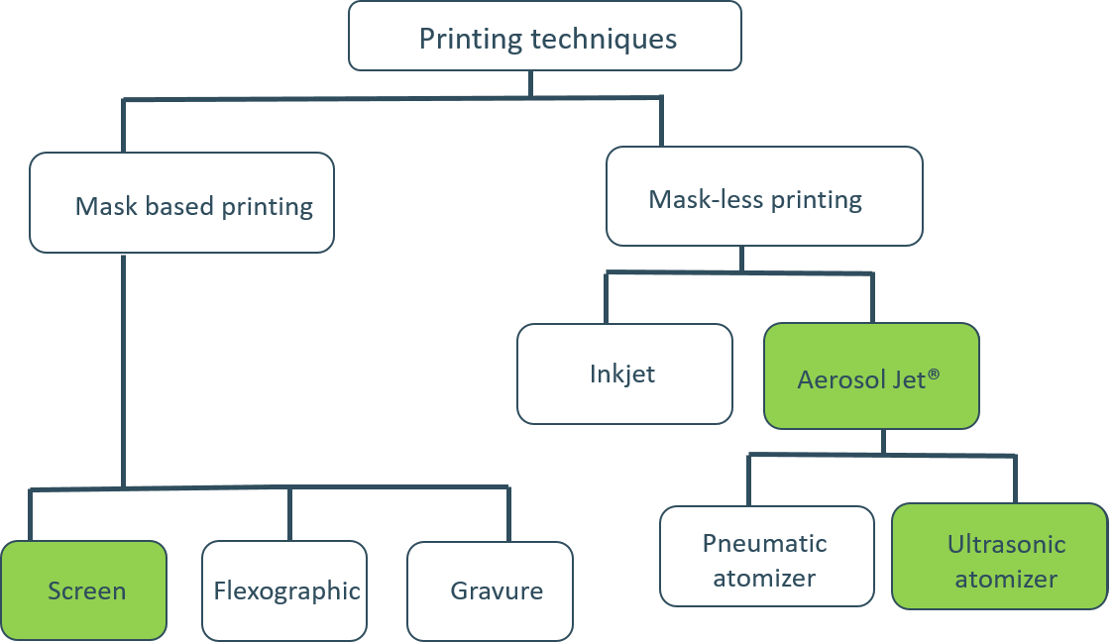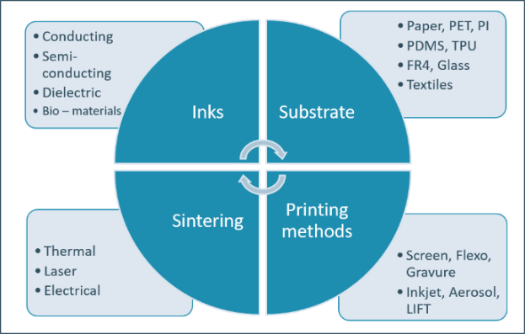of the printing techniques are compiled in figure 2. In this work, AJ®P and Screen Printing are investigated to manufacture a printed antenna on a flexible (paper) substrate, as basic electronics element to develop smart customized devices, such as smart/luxury paper based packages, smart textiles, flexible screens. This work in particular introduced the combined added value of the two techniques in the development of flexible customized smart applications, where the AJ®P technique is used as prototyping process while screen printing as technology towards mass customization. Details of these techniques are presented in the following section 1.1.

Figure 2: Printing technologies are essentially divided in mask based and mask less techniques. This work applies screen and jet based techniques to realise flexible mass customised smart applications.

Figure 1: Inks, substrate, printing technique and sintering are the building blocks of printed electronics (PE)

### Aerosol Jet® Printing and Screen Printing

*Aerosol Jet® Printing (AJ®P)* is a non–contact, direct writing printing technique which allows to print a wide range of functional materials on many different substrates in any designed manner [4], [5]. In this printing technique, an “ink” is aerosolized into an aerosol of ink droplets which typically have a diameter of 1-5 μm [6]. The generation of aerosol is done by an ultrasonic atomizer or pneumatic atomizer. In this work, an ultrasonic atomizer has been used for the generation of the aerosol. This aerosol is entrained in the nitrogen gas and transferred to the deposition head. In the deposition head, a sheath gas is introduced which aerodynamically focuses the aerosol for the printing at the substrate beneath the tip by flowing in the co–axial direction [7], [8]. Such type of processes allows to print feature sizes of 10 µm till several millimeters and thicknesses of 100 nm to tens of microns [7]. Because of the two different atomizing techniques, (AJ®P) allows to print inks with broad viscosities (1-1000 cP) and materials, like metals (Ag, Cu, Au, etc.), conductive polymers (PEDOT:PSS, PANI), carbon based resistive materials, dielectrics, bio–materials (gelatin, collagen[9]), etc. Furthermore, because of the adjustable stand–off distance, i.e. the distance between the nozzle and the substrate, it allows printing directly on 3D/free formed surfaces [5], [10]. There are many different factors in AJ®P which affect the line width (µm), printing quality and the resultant electrical resistance (Ω) of the printed line. Some of the factors are the atomizer gas flow (sccm), the sheath gas flow (sccm), the focusing ratio (sheath gas flow/atomizer gas flow), the plate temperature (°C), the number of printing passes/layers (#), the printing speed (mm/sec), the sintering time (mins), the sintering temperature (°C), the nozzle diameter (⌀), the stand–off distance (mm)…etc. [8], [11].

*Screen printing* (SP) is a direct contact printing technique transferring ink onto a substrate (e.g. paper, glass, plastics, fabrics, etc.) by using a mesh screen with apertures. The open meshes result in the appropriate stencil or printing image while the impermeable coating of the surrounding area blocks the ink deposition [12]. This printing technique uses high viscous (100-100000 mPa.s), thixotropic (shear thinning) inks resulting in a rectangular cross-sectional morphology of the printed pattern [13]. A broad range of functional materials can be deposited, such as metal inks (Ag, Cu, etc.), polymeric inks (e.g. PEDOT:PSS), carbon-based inks, dielectrics… When applying an ink onto a substrate, the squeegee (rubber blade) is moved across the screen, thereby filling the mesh openings with ink. In this forward movement, the screen is momentarily forced to the substrate and the ink is deposited by capillary forces. The blade finally scrapes the ink excess to its initial position and the printing process can be repeated several times to print multiple layers. The maximum printing resolution is tens of microns and the layer thickness of one pass ranges from a few µm to 100 µm, depending on the screen’s mesh size. The main SP parameters include the screen dimensions (e.g. mesh size, mesh thickness…), the printing speed, the squeegee pressure and - hardness, as well as the snap-off distance [14]. In addition, rotary SP can significantly increase the printing speed (> 100 m/min) using a stationary positioned squeegee placed inside a cylindrical screen that rotates at the same rate as the web. This SP method is suitable for large-scale production because of its reliability, but on the other hand it is more expensive and challenging to set up [15].

Aerosol Jet® Printing is used extensively as a tool for Rapid Prototyping and customization in many different sectors of industries whereas Screen Printing is especially implemented for mass customization and production. Both techniques are well known but their output yield is still inferior when compared to the conventional electronics production techniques. AJ®P is successfully applied in 3D printing of 5G antennas for cell phone communication whereas SP is extensively used for batteries, screens and lighting applications. [16], [17]. Section 1.2 discusses advantages and limitations of PE against conventional electronics production technologies, while section 1.3 refers to the applications of PE.

### Conventional Electronics Vs. Printed Electronics technologies

Printed Electronics (PE) is a relatively recent technology as compared to conventional electronics manufacturing steps, like photolithography, etching, wire bonding, IC packing, etc.

Still PE offers many advantages, such as low processing and manufacturing cost when dealing with prototyping, product development and small series production. Manufacturing is also more flexible with respect to design, materials and integration opportunities. Also, it does not need cleanroom facilities, unlike lithographic processes. The conventional electronics industry is especially unable to produce devices with a form factor – i.e. to fabricate electronic devices which can bend, flex or even stretch and that are integrated in a shapeless substrate (as flexible foil, paper, textile…).

On the other hand, PE also offers a number of limitations. The resolution of the printed tracks is still way lower than the conventional electronics. As an example, the best resolution that AJ®P can provide is 10 µm whereas the current EUV (extreme ultraviolet) lithography step can provide a resolution around 20 nm. Even though processes like roll–to–roll can increase the production yield in printed electronics significantly, mass production along with the high accuracy is yet not par level with conventional production techniques. Other limitations of PE over conventional electronics are reliability, durability, down-scaling performance and high-end quality [1], [18].

### Applications of Printed Electronics

Printed Electronics has a diverse range of applications: pressure, humidity, temperature, chemical, etc. printed sensors, antennas, thin–film transistors, photovoltaics, active and passive components, interconnects, batteries, etc. [3], [18]–[20]. The application of PE is also extended towards Neural and Tissue Engineering [21].

Printing of radio frequency identification (RFID) antennas shows promising opportunities in the field of flexible mass customized applications, for example wireless interaction with packages during transportation. In [22], Xu *et al.* have printed an RFID antenna with working frequency of 13.56 MHz using AJ®P and an extra step of electroplating. The electroplating step is an additional step which was implemented on the printed tracks to reduce their printed track resistances. Yuxiao *et al.* have printed an 24 GHz antenna on a 3D printed substrate[23]. In contrast to AJ®P, the domain of screen printed antennas have already been frequently investigated in the recent period by a number of researchers. Shin *et al.* report the use of SP for the development of UHF RFID dipole antennas on PET substrate [24].The work of Fernández-Salmerón *et al.* presents a UHF dipole antenna, directly screen printed on a cardboard package [25]. Janeczek *et al.* instead investigate screen printing to deposit HF RFID antennas on flexible magnetic sheets and polymeric foils [26]. According to the research of A. Pereira *et al.*, the potential of SP to develop near-field communication (NFC) tags on coated paper substrates has also been demonstrated [27].

However, this particular study of printed antenna layouts in the frequency spectrum of HF RFID/NFC applications on paper substrates is rather limited. In addition, the combined use of AJ®P for prototyping and SP for small serial production of customized smart applications has been just little investigated, especially when coming to the use of AJ®P technique. In this paper, this particular application is studied in details. Antenna printing is here taking as an example of PE application. The working frequency, bandwidth and type of an antenna can indeed easily be customized by changing layout, dimensions, and electrical requirements, etc. which is easier for PE rather than for conventional methods.

#### Materials and Methods

### Inks and substrates

The key topic of this study is to investigate antenna printing via Aerosol Jet® Printing and SP by using conductive silver inks on fiber-based printing substrates. Hereby, p_e:smart paper type 2 (Felix Schoeller, Germany) and Algro Baress (Sappi, Southern Africa) were studied. P_e:smart paper type 2 is a white opaque paper-based substrate with hydrophilic nanoporous surface coating, which is specifically made for printed electronics. As reference material, the Melinex series ST 506 transparent PET foil (thickness: 175 µm) from DuPont Teijin Foils and FR4 were used for Aerosol Jet® Printing. In this study, the substrates were not pre-treated.

For the Aerosol Jet® Printing, conductive silver nanoparticle (AgNPs) ink ‘JS-A221AE’ from Novacentrix, Inc, USA was selected and investigated to print antennas. The ink has a sheet resistance of ~24 mΩ/sq/20µm. The viscosity of the ink lies in the range of 20 cP with the average particle size of 35 nm as mentioned in the datasheet of the manufacturer.

For SP, two conductive nano silver inks were selected: ‘Orgacon SI-P2000’ from Agfa-Gevaert (Belgium) and ‘Loctite ECI 1011’ from Henkel (Germany). Both inks are highly conductive with a sheet resistance below 5 mΩ/sq/25µm.

### Printing strategies and equipment

An OPTOMEC AJ300 printer (ultrasonic atomizer) with a nozzle diameter of 300 µm was applied to investigate printing of RFID antennas on paper substrates. Nitrogen was used as the carrier gas. The printed samples were cured for 120 minutes at 120°C in a thermal oven. The atomizer and sheath gas flows were optimized for good continuous printing lines with minimal overspray. Printing speed was in the range of 5 – 7 mm/sec. This is crucial for controlling the deposition of the ink, wetting of the ink on different mentioned substrates and to avoid short circuits in the printed antenna. The printing was performed at room temperature, with 50% relative humidity.

An ISIMAT 1000 PE semi-automatic screen printer with screen mesh: 140 T/cm x 31 µm PET fiber was applied to deposit 4 different antenna designs by SP. As a post-printing step, the ink was cured for 10 min at 150°C in a ventilated box oven. For the set of multilayer prints, the prints were just dried using nitrogen gas for 30 s before printing the next layer.

### Antenna design

RFID is a two-way data transferring method of automatic identification and data capture, consisting of a reader device and a transponder or tag. This tag – with a unique ID – exists of a (printed) antenna to receive/send radio signals and a microchip (for data storage). In this study, passive high frequency antennas are developed resulting in a read range of approximately a few centimetres [28].

The investigated antenna designs are square-shaped, post-it sized loop antennas, each with their own specific number of tracks and track width. These passive HF RFID antennas resonate at 13.56 MHz base carrier frequency and should function with indium gallium zinc oxide thin-film transistor (IGZO TFT) microchips, both designed and developed by Imec (Leuven, Belgium). The main electrical characteristics include the series resistance [Ω], inductance [µH] and RFID functionality by extracting the tags’ code with a reader device Figure 3 shows four different loop antenna designs which are studied in this work.

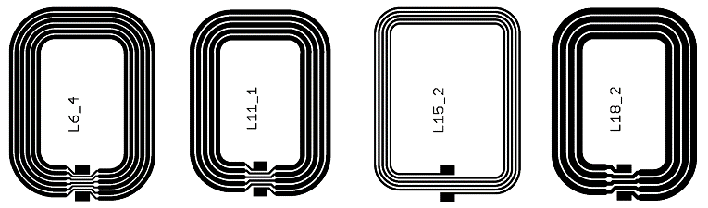 Because of the very limited literature on AJ®P printed antennas on paper, this printing concept was firstly validated by printing a common design of 2.4 GHz antenna (WLAN applications), and its Standing Wave Ratio (SWR) was compared to the theoretical etched antenna; later on, the AJ®P strategy to prototype 13.56 MHz antenna on flexible (paper) substrates for smart packages was fine-tuned and prototypes were realized on various substrates. Sheet resistance of the AJ®P printed pattern was measured by a four-point probe device by Ossila Ltd, UK. The microscopic images were taken by a Hirox KH8700 optical microscope. Standing Wave Ratio (SWR) was measured by ENA series (E5061B), Network Analyzer from Agilent Technologies. Successively, the antenna layouts of figure 3 were screen printed on p_e:smart paper type 2 by using the Orgacon and Loctite nano silver inks. For each ink-paper-design combination, 25 different antennas were deposited for a total of 200 antennas, as show case of the ability of screen printing to scale-up customised smart devices to (small) serial production. The screen printed antenna’s layouts were electrically characterized on RFID functionality with the thin-film microchip by extracting the tag’s code.

#### Results and discussion

* 1. Aerosol Jet® Printed Antennas

*Comparison with etched antennas:* Figure 4 shows the Standing Wave Ratio (SWR) of a 2.4 GHz (working frequency (fc)) antenna by AJ®P with Metalon® ‘JS-A221AE’. The SWR (Standing Wave Ratio) was measured with a Network

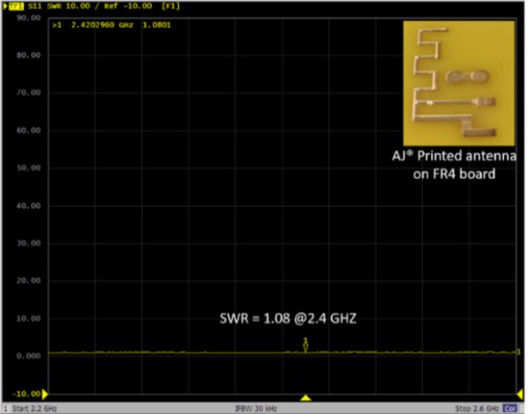

Figure 4: Standing Wave Ratio (SWR) of a 2.4 GHz Aerosol Jet® Printed antenna on a FR4 board for the sake of comparison with conventionally etched antenna (i.e. on rigid substrates). A SWR of 1:1 means exact impedance matching and no loss in the transmission line.

Analyzer. In an ideal case, SWR of 1:1 means exact impedance matching and no loss in the transmission line. In our case, SWR is 1.08. This portrays the close match of the impedance of the load and the impedance of the transmission line carrying the RF signal between AJ®P and conventionally etched antenna design. This infer that the AJ®P can be enabling tool for the fabrication of any antenna layout.

*Electrical characterization of printed tracks on different substrates:* Figure 5 shows the variation of sheet resistance vs the number of AJ® printed layers for various rigid and flexible substrates, including paper. The investigation is necessary to fine tune the AJ®P strategy to prototype printed antennas for customised applications on flexible (paper based) substrates, as luxury, smart packages, e.g. enabling to identify the content status. It can be seen that the sheet resistances decrease significantly until layer 4 and then starts to saturate relatively. This decrease of the resistance is due to the increase in the thickness of the printed tracks. All the substrates follow a similar trend, for exception of PET foils, as comparison, thefirst layer provides relatively high sheet resistance (576 ± 0.675 mΩ/sq) values as compared to the other substrates but starting from 2 layers, the sheet resistance values are in the same range as the other antennas. The reason for higher resistance value of the first layer of the Ag ink on the PET foil could be the first layer is not conductive enough due to less amount of material deposited and chemical interaction of ink-substrate.

*Prototyping of Antennas on different substrates:* Figure 6 shows the digital images of the printed tracks of the printed antennas (L6 design) on different types of substrates, including paper. The print quality is good, without overspray, fully dense and continuous. This also reveals the ability of AJ®P to print on a different class of substrates. Successful printing was done on FR4, PET and two different paper substrates.

Figure 3: Designs of high frequency RFID loop antennas with number of turns ranging from 4 to 6 turns, variable linewidth from 500 µm to 1600 µm and interspace ranging from 400 to 500 µm. The total size is in the range of 40 mm x 50 mm. Lx labels are the specific label investigated.

FR4 was chosen as positive reference against conventional etching process. The rest of the substrates, two different types of papers and PET, are intrinsically flexible substrates which provide the flexibility and bendability to the printed prototypes of the antennas. These prototypes were not characterized but they showcase the potential of AJ®P to be a successful technology for Rapid Prototyping of flexible devices.

The series resistances of the antennas printed on Algro Baress, PET, p_e:smart paper type 2 and FR4 are 21 Ω, 51 Ω, 65 Ω, 49 Ω, respectively. All the antennas except p_e:smart 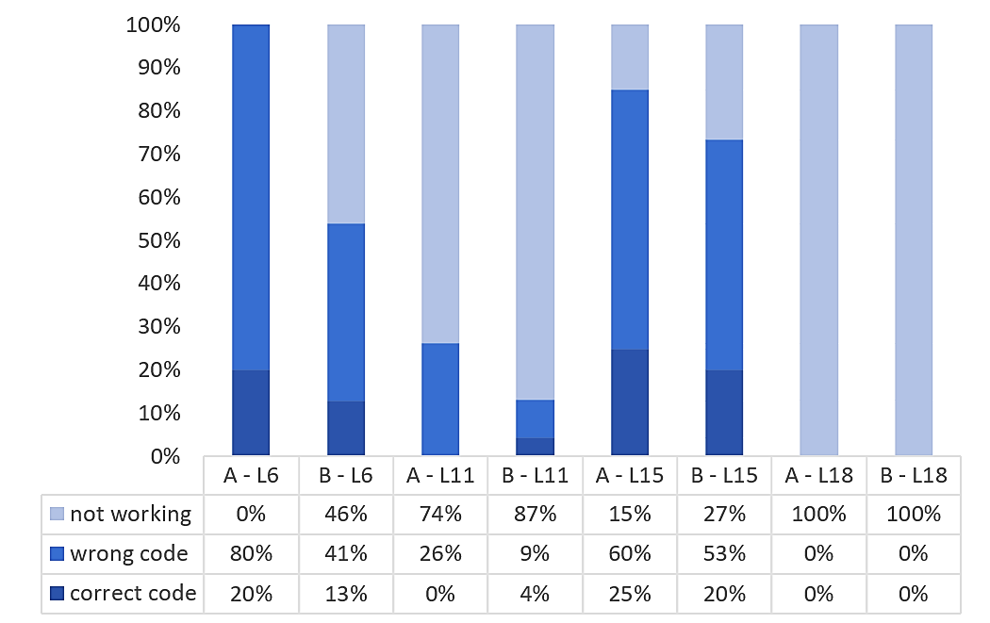paper type 2 were printed with 4 layers. A number of limitations, in case of AJ® Printing of the HF RFID, were also identified:

* Long printing time (~ 2 hrs for an antenna design)
* Low sintering temperature preferred for paper substrates
* Problems in adhesion and wetting with p_e:smart paper type 2

Electrical series resistance meet the requirements for the functional antenna and good quality printing has been observed.

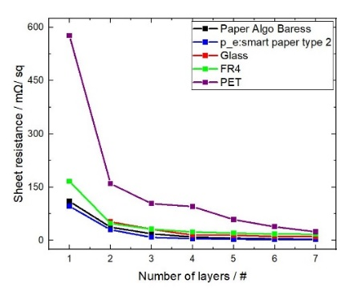

Figure 7: RFID functioning of printed antennas on p_e:smart paper type 2 (A: ‘Orgacon SI-P2000’ and B: ‘Loctite ECI 1011’

Figure 5: Sheet resistance vs n.# of Aerosol Jet® Printed layers with silver ink JS-221AE on different substrates.

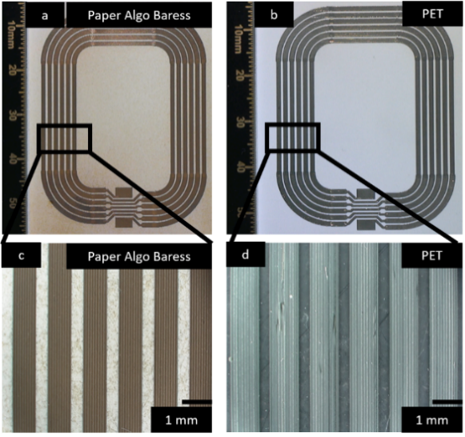

Figure 6: Digital images of AJ® Printed L6 design antenna tracks on (a) Algro Baress (b) PET (c) printed tracks of antenna on Algro Baress 2 (d) printed tracks of antenna on PET

### Screen Printed Antennas

Fig.7 shows the performance obtained for the screen printed antennas, in function of the particular design, ink and substrates used. As shown, due to the diversity in ink composition, track width, loop design and loop distance, the correct RFID functioning alters significantly for each ink-paper-design combination (Figure 7).

The L18 design did not generate functional antennas, i.e. no

communication occurred between the thin-film microchip and the reader device. The high track width of this design results in too low values of series resistance (19,3 ± 0,2 Ω) to pass the RFID functioning. In general, the L11 design does also not result in functional antennas while the other designs (L6 and L15) correspond moderately to the working range of the microchip’s bandwidth. The entire selection of L6 antennas printed with ‘Orgacon SI-P2000’ ink transmits any code from the microchip to the reader device. This ink-paper-design combination looks most promising for printed HF RFID antennas and for that reason, the L6 antenna design is selected for further investigation.

As second step of the printed antenna development, the standard label material Algro Baress was investigated regarding printability of functional HF RFID antennas. Hereby, both conductive nano silver inks were screen printed 10 times referring the L6 antenna design. Based on the RFID functioning test, the series resistance and the inductance measurements, the antennas printed with ‘Orgacon SI-P2000’ ink showed unfavorable results: 90% of the antennas were not functional. The inductance of the non-working antennas was 2,13 ± 0,17 µH resulting in too high values of the antennas’ quality parameter Q (Equation 1)

$Q= \frac{R}{2 ∙ π ∙ f ∙ L}$ (1)

with R is the series resistance [Ω], f is the frequency [Hz] and L is the inductance [H]. Too low Q values indicate weak energy transfer and other limitations that prevent data from being filtered. In contrast, too high Q values (as observed) indicate that a big amount of energy is being captured by the antenna and for that reason, the antenna functions as a filter for the requested data. Nevertheless, one tags’ code of this ink-paper combination could be correctly extracted with the reader device; the antenna’s inductance and series resistance were 2,92 µH and 48,3 Ω, respectively.

In contrast to ‘Orgacon SI-P2000’, the deposition of ‘Loctite ECI 1011’ ink onto the Algro Baress substrate led to 100% of functional L6 antennas. The inductance and series resistance were 2,98 ± 0,01 µH and 23,4 ± 1,2 Ω, respectively. According to Equation 1, the antennas has a Q factor of 0,09 resulting in complete functionality with the thin-film microchip. Hence, the combination of ‘Loctite ECI 1011’, Algro Baress substrate and L6 antenna design is concluded to be successful for SP passive HF RFID antennas on paper substrates. Hereby, the antenna’s inductance value should be approximately 3,00 ± 0,10 µH to meet the requirements of RFID functioning with the used IGZO-TFT microchip. The electrical resistance and inductance of this combination meets the requirements for the 100% functioning of the multiple printed antennas with the microchip. It showcases the SP can be effective tool for producing reliable customized antennas.

#### Conclusions:

In the context of AJ®P, different rigid and flexible substrates were investigated with test designs. By using those parameters, design L6 was printed on four different substrates. This showcased the potential of AJ®P as a rapid prototyping method whereas SP is more favourable for end product for flexible mass customized applications.

Flexible HF RFID antennas designs were printed by SP on fiber-based paper substrates and characterized successfully. This antenna is chosen as a single printed element out of numerous applications of PE. Different inks, substrates and designs were investigated to find out the optimal ink-paper-design combination (Loctite ECI 1011, Algro Baress, L6 design) for SP on the basis of printability, performance and antenna functionality. The functionality of this HF RFID antenna can be used in the “smart-packaging” applications of numerous products.

The successful prototyping by AJ®P of fully printed customized antenna and SP of functional antenna infers that these printing methods can be used as production method in the value chain. This implies that Printed Electronics can be an enabling technology for the development and manufacturing of flexible mass customized electronics applications and devices.

#### Acknowledgments

The authors would like to express gratitude to the Agentschap ‘Innoveren & Ondernemen’. Apart from that, sincere thanks to all the partners of the project PAPERONICS especially Fetra vzw. This study is part of the CORNET project ‘PAPERONICS: Low cost multisensory paper & packaging applications’ (2019-2020). It is funded by Flanders Innovation & Entrepreneurship (VLAIO), Belgium (HBC.2018.0225) and AiF - German Federation of Industrial Research Associations, Germany. This work is also part of the TETRA 3D ElektroPrint -3D printen van vrije vorm elektrische/elektronische toepasssingen -HBC.2016.0067, also funded by VLAIO. Lastly, Jurre de Weerdt and Marc Scheirs are acknowledged for their expertise in 2.4 GHz antenna measurements.

#### References

[1] K. Suganuma, Introduction to printed electronics (SpringerBriefs in electrical and computer engineering). 2014.

[2] W. Wu, “Inorganic nanomaterials for printed electronics: a review,” Nanoscale, vol. 9, no. 22, pp. 7342–7372, 2017.

[3] F. B. Kessler, F. B. Kessler, S. Khan, L. Lorenzelli, R. Dahiya, and S. Member, “Technologies for Printing Sensors and Electronics Over Large Flexible Substrates : A Review Technologies for Printing Sensors and Electronics over Large Flexible Substrates : A Review,” IEEE Sens. J., vol. 15, no. June, pp. 3164–3185, 2015.

[4] J. M. Hoey, A. Lutfurakhmanov, D. L. Schulz, and I. S. Akhatov, “A Review on Aerosol-Based Direct-Write and Its Applications for Microelectronics,” J. Nanotechnol., vol. 2012, pp. 1–22, 2012.

[5] N. J. Wilkinson, M. A. A. Smith, R. W. Kay, and R. A. Harris, “A review of aerosol jet printing—a non-traditional hybrid process for micro-manufacturing,” Int. J. Adv. Manuf. Technol., 2019.

[6] E. B. Secor, “Principles of aerosol jet printing,” Flex. Print. Electron., vol. 3, no. 3, p. 035002, Sep. 2018.

[7] M. Smith, Y. S. Choi, C. Boughey, and S. Kar-Narayan, “Controlling and assessing the quality of aerosol jet printed features for large area and flexible electronics,” Flex. Print. Electron., vol. 2, no. 1, p. 015004, Mar. 2017.

[8] A. Mahajan, C. D. Frisbie, and L. F. Francis, “Optimization of aerosol jet printing for high-resolution, high-aspect ratio silver lines,” ACS Appl. Mater. Interfaces, vol. 5, no. 11, pp. 4856–4864, 2013.

[9] R. Gibney, S. Matthyssen, J. Patterson, E. Ferraris, and N. Zakaria, “The human cornea as a model tissue for additive biomanufacturing: a review,” Procedia CIRP, vol. 65, pp. 56–63, 2017.

[10] M. Hedges and A. B. Marin, “3D Aerosol Jet® Printing - Adding Electronics Functionality to RP/RM,” WHITEPAPER - Optomec, pp. 14–15, 2012.

[11] W. Verheecke, M. Van Dyck, F. Vogeler, A. Voet, and H. Valkenaers, “Optimizing aerosol jet® printing of silver interconnects on polyimide film for embedded electronics applications,” 8th Int. DAAAM Balt. Conf. "INDUSTRIAL Eng., no. April, pp. 373–379, 2012.

[12] S. M. F. Cruz, L. A. Rocha, and J. C. Viana, “Printing technologies on flexible substrates for printed electronics,” in Flexible Electronics, IntechOpen, 2018.

[13] J. Ding et al., “Preparing of highly conductive patterns on flexible substrates by screen printing of silver nanoparticles with different size distribution,” Nanoscale Res. Lett., vol. 11, no. 1, pp. 1–8, 2016.

[14] B. Fasolt, M. Hodgins, G. Rizzello, and S. Seelecke, “Effect of screen printing parameters on sensor and actuator performance of dielectric elastomer (DE) membranes,” Sensors Actuators A Phys., vol. 265, pp. 10–19, 2017.

[15] B. Roth, R. Søndergaard, and F. Krebs, “Roll-to-roll printing and coating techniques for manufacturing large-area flexible organic,” Handb. Flex. Org. Electron. Mater. Manuf. Appl., pp. 171–192, 2014.

[16] W. Yang et al., “A Breathable and Screen-Printed Pressure Sensor Based on Nanofiber Membranes for Electronic Skins,” Adv. Mater. Technol., vol. 3, no. 2, p. 1700241, Feb. 2018.

[17] R. Cao et al., “Screen-Printed Washable Electronic Textiles as Self-Powered Touch/Gesture Tribo-Sensors for Intelligent Human–Machine Interaction,” ACS Nano, vol. 12, no. 6, pp. 5190–5196, Jun. 2018.

[18] Z. Cui, “Applications and future prospects of printed electronics,” in Printed Electronics: Materials, Technologies and Applications, Wiley Online Library, 2016, pp. 316–338.

[19] S. Nagels, R. Ramakers, K. Luyten, and W. Deferme, “Silicone devices: A scalable DIY approach for fabricating self-contained multi-layered soft circuits using microfluidics,” in Proceedings of the 2018 CHI Conference on Human Factors in Computing Systems, 2018, pp. 1–13.

[20] F. Molina-Lopez et al., “Inkjet-printed stretchable and low voltage synaptic transistor array,” Nat. Commun., vol. 10, no. 1, pp. 1–10, 2019.

[21] M. Seiti, P. Ginestra, R. M. Ferraro, E. Ceretti, and E. Ferraris, “Nebulized jet-based printing of bio-electrical scaffolds for neural tissue engineering: a feasibility study,” Biofabrication, vol. 12, no. 2, p. 25024, 2020.

[22] B. Xu et al., “Aerosol jet printing on radio frequency identification tag applications,” Key Eng. Mater., vol. 562–565, pp. 1417–1421, 2013.

[23] Y. He, C. Oakley, P. Chahal, J. Albrecht, and J. Papapolymerou, “Aerosol Jet printed 24 GHz end-fire quasi-Yagi-Uda antenna on a 3-D printed cavity substrate,” 2017 Int. Work. Antenna Technol. Small Antennas, Innov. Struct. Appl. iWAT 2017, pp. 179–182, 2017.

[24] D.-Y. Shin, Y. Lee, and C. H. Kim, “Performance characterization of screen printed radio frequency identification antennas with silver nanopaste,” Thin Solid Films, vol. 517, no. 21, pp. 6112–6118, 2009.

[25] J. Fernández-Salmerón, A. Rivadeneyra, F. Martínez-Martí, L. F. Capitán-Vallvey, A. J. Palma, and M. A. Carvajal, “Passive UHF RFID tag with multiple sensing capabilities,” Sensors, vol. 15, no. 10, pp. 26769–26782, 2015.

[26] K. Janeczek, A. Arazna, B. Salski, K. Lipiec, and M. Jakubowska, “Printed HF antennas for RFID on-metal transponders,” Circuit World, 2016.

[27] A. Pereira et al., “Near-field communication tag development on a paper substrate—application to cold chain monitoring,” Flex. Print. Electron., vol. 3, no. 1, p. 14003, 2018.

[28] A. Perrin and M. Souques, Electromagnetic fields, environment and health. Springer Science & Business Media, 2013.

Aerosol Jet® Printing of a HF RFID Antenna on Fibre-based Paper Substrates for Smart Packaging

**Abstract:** Aerosol Jet® Printing (AJ®P) is a relatively new direct-write printing technique for the fabrication of smart, flexible electronic applications especially for using fibre-based paper as a substrate for the smart packaging industry. This topic has not been explored much yet. In this work, 17 different paper substrate were characterized based on their properties like surface roughness, ink penetration behavior, and so on and silver ink was deposited using AJ®P to create electronic interconnects. Silver nano-particle (AgNP) ink, which is compatible with the ultrasonic atomizer of the AJ® printer was used in this work. The electrical resistance of the printed tracks using AJ®P was recorded and used also as a parameter to choose the appropriate substrate for the printed applications. Smooth papers which do not absorb ink (less porous) reveals less electrical resistance values of the printed tracks. The reliability and durability of these printed tracks were checked also by doing several stress tests (e.g., climate aging, rub resistance, etc.). A smart and flexible electronics applications like HF RFID printed antenna was fabricated using AJ®P on the selected paper and was further validated with its frequency response. This concludes that AJ®P can be used as a printing technique to print flexible applications which can be used in the smart-packaging industry which has not been explored previously.

Keywords: Aerosol Jet® Printing, fibre-based paper substrates, RFID, smart packaging, smart electronic applications

1. Introduction

Paper, as known, is one of the most common materials used in the graphic printing and packaging industry. Paper is known to be bio-degradable, low-cost, lightweight, flexible, and easy to produce. The paper material containing the natural cellulose fibres is biodegradable and biocompatible which makes it easier to recyclable, eco-friendly, and “green”. These are a few advantages that have intrigued researchers to use paper as a substrate for PE aiming to address the need for eco-friendly, sustainable, flexible, customized smart electronic devices aiming for numerous industries like smart packaging [1]–[9].

“Traditional Packaging” is used to ensure the good quality of the product during its product life cycle and also helps in mitigating the risk of physical damage to the product of any kind like in storage facilities or transportation [10]. The traditional packaging industry lacks in providing the real-time status of the product condition to the customers. This issue is being tackled by the means of a broad category- “Smart Packaging”[10]. This umbrella term is further classified as “Active Packaging” & ”Intelligent Packaging”.

Active packaging refers to packaging with added functionality such as incorporating oxygen or ethylene scavengers, anti-oxidant release, anti-microbial coating, moisture control function, CO2 absorbers, and emitters, etc. [11]. Active packaging components lack in providing the status, quality, and shelf life to the user but this can be achieved by adding intelligent components, such as indicators, sensors, and RFID systems to monitor the product or communicate about the status. This ability to provide the information, condition, and integrity of the product is referred to as “Intelligent Packaging” [12], [13]. According to IDTechEx report, the global demand for electronic smart packaging devices will reach $ 1.7 Billion in the year 2022-23.

For added functionality in intelligent packaging, RFID (Radio Frequency Identification) is commonly used. It is a wireless system and along with QR codes, bar codes, etc. comes under the umbrella of Automatic Identification (AID). RFID tag, also known as “label”, consists of an RFID chip (for data storage) and a (printed) antenna, which can perform two-way communication with the reader (i.e. transmitter or receiver) with the help of electromagnetic (EM) waves. RFID tags can be powered by external power like solar cells or battery (i.e. Passive Tags), or can be self-powered by harvesting the energy from the reader (i.e. Active Tags) and can be powered both by external & internally harvested power (i.e. Semi-Active Tags). These tags can be classified into three major categories according to their working frequency and are mentioned in table 1 [10], [14], [15], [16]. In this study, a passive HF RFID tag is designed, manufactured, and validated.

|  |  |
| --- | --- |
| Category | Frequency Range |
| Low Frequency (LF) | 125-134 KHz |
| High Frequency (HF) | 13.56-15.55 MHz |
| Ultra-High Frequency (UHF) | 865-956 MHz |

Table 1. Classification of RFID tags working frequency range

Conventionally, an antenna can be fabricated using subtractive techniques like etching and photolithography but due to its complex processing steps, and the need of high-cost machinery and infrastructure, Additive Manufacturing technique - Printed Electronics (PE) is preferred and chosen. PE is a deposition technique of a functional material/ inks (metal, polymers, dielectrics, etc.) on a substrate (flexible, rigid, stretchable, free-form) with the help of either conventional (screen, gravure, etc.) or a digital printing (inkjet, Aerosol Jet®) technique [17].

There have been already many recent developments where cellulose fibres based paper is being used as a substrate for PE [18]. Such a paper can be referred to as “smart paper” [8]. Manufacturing of many active and passive electronic components and devices like sensors [10], antennas [17], [20], [21], batteries [22], transistors [23], electrochromic displays [24], solar cells [25], etc. have reported with paper as a chosen substrate. The applications of such devices range from different industrial and commercial sectors.

Printing of RFID antenna using conductive metal-based silver (Ag) ink on paper substrates implementing different printing techniques has been investigated previously. Considering digital inkjet printing, K. Sangkil et al., show the capability of inkjet printing of microwave active/passive systems on cellulose and synthetic papers for Internet-of-Things (IoT) and “Smart-skin” applications. [1], [26]. L.Vasileiso et al., claim to be the first to use inkjet printing on the paper towards the first integrated wireless sensor network infrastructure using RFID-enabled sensor nodes for autonomous wearable sensing applications [27]. A. Rida et al., also used inkjet printing on flexible low-cost paper substrates for RFID and WSN applications [28]. Other conventional techniques like Screen Printing [29]–[32], Flexographic Printing [33], [34] and Gravure Printing [35] were also investigated for similar applications.

Xu et al*.* have printed an RFID antenna with a working frequency of 13.56 MHz using AJ®P but with an extra step of electroplating. The electroplating step is an additional step that was implemented on the printed tracks to reduce their printed track resistances [17], [36]. In this study, Aerosol Jet® Printing (AJ®P) is exclusively used as a novel printing technique to realize HF RFID antenna on a paper substrate.

*Aerosol Jet® Printing (AJ*®*P)* is a non–contact, direct writing printing technique which allows the printing of a wide range of functional materials on many different substrates for any intended design [37], [38]. In this printing technique, an “ink”/ functional material is aerosolized into an aerosol of ink droplets which typically have a diameter of 1-5 μm [39]. The generation of aerosol can be done by an ultrasonic atomizer or pneumatic atomizer depending upon the viscosity of the ink. This aerosol is entrained in the nitrogen gas and transferred to the deposition head. In the deposition head, a sheath gas is introduced which aerodynamically focuses the aerosol for the printing at the substrate beneath the tip by flowing in the co–axial direction [40], [41]. AJ®P allows printing feature sizes of 10 μm to several millimeters and thicknesses of 100 nm to tens of microns [40]. Considering this range of resolution, AJP is an ideal choice for printing complex antennas to avoid short circuits. Because of the two different atomizing techniques, (AJ®P) allows printing inks with broad viscosities (1-1000 cP) and materials, like metals (Ag, Cu, Au, etc.), conductive polymers (PEDOT:PSS, PANI), carbon-based resistive materials, dielectrics, biomaterials (gelatin, collagen [42]–[46]), etc. Furthermore, because of the adjustable stand–off distance, i.e. the distance between the nozzle and the substrate, it allows printing directly on 3D/free-formed surfaces [47]. Many different factors in AJ®P affect the line width (μm), printing quality, and the resultant electrical resistance (Ω) of the printed line. Some of the factors are the atomizer gas flow (sccm), the sheath gas flow (sccm), the focusing ratio (sheath gas flow/atomizer gas flow), the plate temperature (°C), the number of printing passes/layers (#), the printing speed (mm/sec), the sintering time (mins), the sintering temperature (°C), the nozzle diameter (⌀), the stand– off distance (mm)…etc. [17], [39], [41].

This study is initiated by acquiring and testing 17 fibre-based substrates and conductive silver ink, which are provided by stakeholders in the smart packaging supply chain. First, the influence of paper properties – such as surface roughness of the paper and electrical resistance of the printed ink for Aerosol Jet® printing is investigated. Not only that, mechanical and optical characteristics, along with thermal degradation was considered for the pre-selection of the substrates. A suitable substrate was chosen after considering all the above-mentioned characteristics. for printed electronics are selected based on their printability and ink compatibility performance. Next, conductive silver ink, fibre-based substrate, print design, and print parameters are combined to develop an Aerosol Jet® Printed HF RFID antenna which is validated. The detailed methodology is explained in Figure 1.

The overall objective of this study is to showcase the capability of Aerosol Jet® Printing on rapid prototyping of smart electronics applications (like RFID antenna) on fibre- based substrates such as paper. Since there is very limited literature in the context of Aerosol Jet® Printing on paper substrates, this study is crucial and will be informative for the PE community. The specific objective aims at the printing of AgNP ink on different fibre-based substrates like paper. Furthermore, the selection of appropriate paper substrates was done based on their surface roughness, thermal withstanding temperature, visual and mechanical properties. The ink-substrate penetration interaction was optically investigated as well to ensure good adhesion of printed deposited ink on the substrates After acquiring the best combinations of ink-substrate, HF RFID antennas for smart packaging were printed and functionality tested.

This paper is one of the first papers to implement Aerosol Jet® Printing to prototype and fabricate RFID antennas on a fibre-based substrate. Such studies have the potential for future implementation of Printed Electronics (PE) in sustainable smart packaging

2. Materials and Methods

2.1 Inks and Substrates

An aqueous-based silver dispersion (Metalon® JS-A221AE ink (Novacentrix Inc., USA ) was chosen to print silver interconnects and RFID antenna. It is an electrically conductive silver nanoparticle (AgNPs) ink, specially designed for the ultrasonic atomization of AJ®P. The viscosity of this complex nanofluid lies in the range of 10-20 cP with a silver content of 50% wt as the filler particle (AgNPs). According to the datasheet provided by the manufacturer, the average dispersed particle size of these AgNPs is 35 nm. The sheet resistance of the printed ink on a glass substrate with a thickness of 18 µm is ~ 24.2 mΩ./sq.

For the substrates, 17 fibre-based papers were provided by multiple suppliers (stakeholders) in Belgium and Germany. The substrates were different in their value of surface roughness (Ra), thickness (µm), basis weight (g/m2), physical and visual appearance, and so on. The surface roughness measurements were measured with a Brucker Dektak XT stylus profilometer, at the IMO-IMEC, Hasselt University, Belgium. Details of all the paper substrates are summarised in Table 5.

2.2. The Aerosol Jet® Printing Process

An Aerosol Jet® Printer AJ 300 (Optomec Inc, Albuquerque, NM, USA) was used to deposit the mentioned ink on the different sets of substrates. This machine is equipped with an ultrasonic and pneumatic atomization mode. In this research, ultrasonic atomization was adopted. The Metalon® JS-A221AE ink is indeed especially formulated for ultrasonic atomization and its use is ideal with this machine at this setup. ~1 ml of this ink is sufficient to obtain reliable atomization with the ultrasonic method. The print nozzle diameter can range from 100 µm to 300 µm. The nozzle diameter (Ø) used in this work was 300 µm, and it was provided by the printer manufacturer. Nitrogen gas (N2) was used as a carrier gas for the transport of the atomized particles for the deposition from the nozzle, as described in the introduction section. The printer can offer a ~20 µm printed line width with a 20 µm pitch size and the thickness of the single printed layer can range from 100 nm to more than 5 µm, as per the datasheet provided by the manufacturer. The position accuracy and position repeatabilities are ±5 µm & ±2 µm. Sample printing was conducted at room temperature (23°C) in relative humidity of 50 %. The platen temperature (temperature of the printer stage) was also kept at room temperature. All the printed interconnects and electronic circuits were thermally sintered in a conventional thermal oven from Heraeus, DE. The printing experiments were conducted at the Advanced Manufacturing Laboratory (AML), Campus De Nayer, KU Leuven, Belgium.

2.3. The experimental methodology

An experimental study was conducted to identify a suitable fibre-based substrate out of the 17 acquired papers, as support for the foreseen application, and to get insight into the ideal characteristics of a fibre-based substrate for smart packaging, given a commercially available AJ®P optimized nano-ink along with typically used print parameters. Due to several factors, like surface roughness, porosity, etc, of the substrates, the ink-substrate interaction is indeed different for each combination which is discussed later the section 2.3.2.

As a first approach, the electrical test circuit was printed on different papers, and their electrical resistance R (Ω) was recorded with a multi-meter and evaluated. Secondly, the interaction ink-substrate was evaluated by analysing the penetration depth of the printed patterns along with the stress tests performed on the printed samples. Other factors like the effect of the sintering on the different papers, the surface roughness of the substrate, printability on the paper, visual & mechanical, and so on were also observed. This methodology facilitated to choose the appropriate substrate for our application (HF RFID antenna).

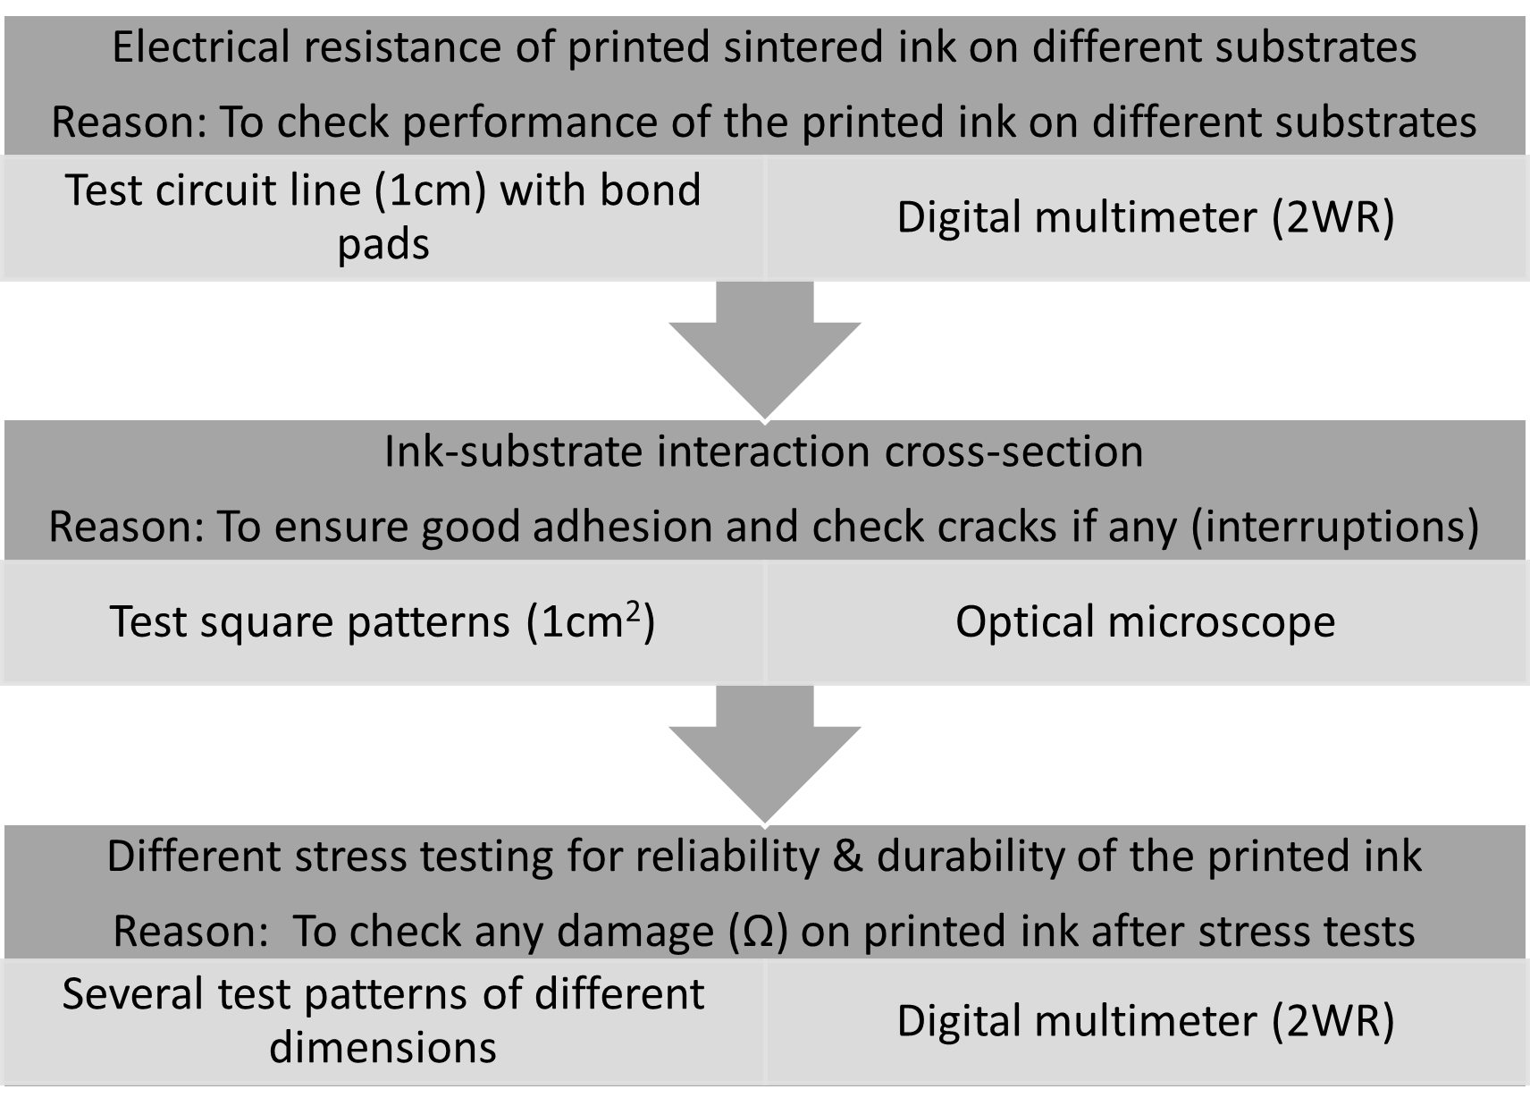

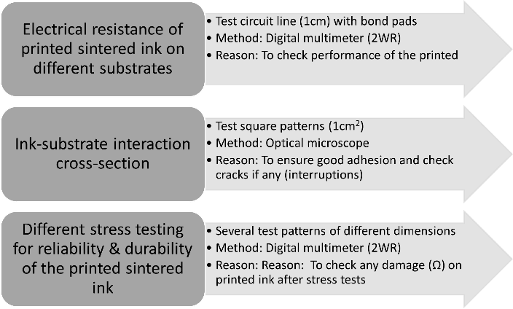

**Figure 1.** Flow chart of the experimental methodology applied. (choose one image out of the 2)

2.3.1 Electrical performance of printed lines on different papers

As a basic electrical element, a test line, 10 mm long, with 3×3 mm bond pads at the edges was printed on all 17 paper substrates (Fig.1) The investigated factors were the different papers while the response of interest was the electrical resistance R(Ω) of the printed lines. The electrical resistance R(Ω) was measured via 2 wire method (2WR), by the means of a Rigol DM3068 6½ Digit Digital Multimeter. The printing parameters and sintering conditions are listed in Table 2. These conditions were chosen due to the previous studies and knowledge of Aerosol Jet® Printing of the author. The printed elements were also inspected via optical microscopy at different magnifications, and optical pictures were captured with an HR800 Hirox optical microscope (at KU Leuven, Belgium) for any interruptions, failure, delamination, or cracks.

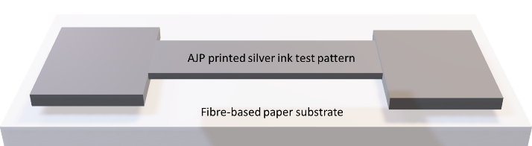

**Figure 2.** Schematics of the experimental set-up and printed sample towards paper selection. The printed line is a 10 mm long interconnect across two 3x3 mm bond pads which allows the measurement of the electrical resistance of the printed pattern.

|  |  |
| --- | --- |
| **Printing and sintering conditions** | **Values used** |
| Atomizer gas (sccm) |  |
| 55 |
| Sheath gas (sccm) | 45 |
| Print speed (mm/sec) | 15 |
| Platen temperature (°C) | 23 |
| Number of layers | 10 |
| Sintering time (mins) | 120 |
| Sintering temperature (°C) | 150 |

**Table 2.** AJ®P printing parameters and sintering conditions.

2.3.2 Ink-substrate interaction-cross-section inspection

The test square patterns with an area of 1 cm2 were printed with AJ®P on the different paper substrates (selection results have been described in Section 3). The printing parameters were the same as in section 2.3.1. However, 4 layers were printed instead of 10 to increase the print efficiency and reduce the printing time. Furthermore, the sintering time was increased to minimum 180 minutes and the sintering temperature decreased to 110 °C to avoid the thermal degradation and curling effect of the substrates which was observed from the previous step of experimental methodology mentioned in Section 2.3.1. The purpose to perform this experiment is mainly to analyse the ink-substrate penetration and adhesion performance because interruptions of the ink film may lead to difficulties in the functionality (conductivity) of the structures.

Hence, cross-sections of printed samples were inspected by employing a high-resolution 3D-microscope (Keyence VHX-900F Digital Microscope) at the Papiertechnische Stiftung Institute (Dresden, Germany). The thickness of the printed lines was analysed via image processing to estimate the penetration depth of the material at the selected experimental conditions. The resolution chosen was 1600×2000 with a magnification of 2000X. 3 images were taken per sample and 5 measurements were taken for an image.

2.3.3 Stress tests upon printed pattern

Four critical stress tests were chosen and performed on the printed ink tracks to investigate the effect on the electrical resistance R(Ω) of the printed tracks upon these stress tests. The approach toward such tests was to record the electrical resistance R(Ω) before and after tests using a digital multi-meter (2WR). Such kind of stress tests was done to ensure the reliability and durability of the printed tracks. These accelerated testing are common to realize and mimic the real-time environment situation. In Table 3, the tests and their details are summarized. The tests were performed at Papiertechnische Stiftung Institute (Dresden, Germany).

The chosen fibre-based paper substrate for this investigation was Koehler Type B (KTB) with PVOH coating. Metalon® JS-A221AE ink (Novacentrix Inc., USA ) was chosen to print silver test structures that were investigated. For the climate aging test, the samples were subjected to climate treatment in a climatic chamber. The XENOTEST ALPHA HE device (ATLAS Material Testing Technology GmbH, Germany) was used for the examination. The rub resistance was determined by a rub resistance tester -Prüfbau-Quartant.

|  |  |  |
| --- | --- | --- |
| **Test Name** | **Test Details** | **Sample**  **Dimension** |
| Accelerated Aging  (Climate Aging) | Samples kept in a climate chamber @  (80 ±0,5)°C / (65 ±2)%. |  |
| Aging duration of 12 days | Custom |
| DIN ISO 5630-3 |  |
| Accelerated Aging  (Light Aging) | Samples exposed to light. |  |
| Illumination with xenon arc light.  Irradiation levels, dose, filters, temperatures can be changed.  DIN EN ISO 4892-2 | 135 × 45 mm |
| Rub Resistance | Rub length: 4.5 cm at a rub speed of 66 strokes per minute.  Abrasive round body mass: 610 g | 45 × 45 mm |
| Water Resistance | Samples exposed to 0.1 ml water | Custom |
| 30-60 seconds  ISO 18935 Methods |  |

**Table 3.** Summary of the stress tests performed on the printed tracks with the test name, details and their characteristics

2.4 Case study

In this paper, a case study of a HF RFID antenna was designed, fabricated, and validated by implementing Aerosol Jet Printing with the help of conductive AgNPs ink on a fibre-based paper substrate. The silver ink Metalon® JS-A221AE ink (Novacentrix Inc., USA) is used along with the chosen substrate - Koehler Type B (coated). This case study is an example of the many applications which AJ®P as a printing technology can exploit on fibre-based substrates in the area of smart packaging like printed bar-code, or smart RC circuits along with LEDs. In the following sub-sections, the case study will be explained and their results will be discussed in the result section 3.

2.4.1 RFID Antenna

The investigated antenna design is a square-shaped, 6 loops antenna. It resonates at 13.56 MHz (HF-RFID) resonance frequency (fc­­) for Near-Field Communication (NFC) and is capable of functioning with indium gallium zinc oxide thin-film transistor (IGZO TFT) microchips, both designed, developed, and tested by IMEC, Leuven, Belgium. It is also described by Machiels and Verma *et al*. [17] and [21].

The main electrical characteristics include the electrical resistance R[Ω], inductance H[μH], and RFID functionality by extracting the tags code with a reader device.

The antenna is printed using AJ®P on fibre-based substrates with AgNPs ink and can later be integrated into a package for smart packaging applications. Hereby, in Figure 3, the design of an antenna along with its characteristics are compiled in Table 4.

|  |  |
| --- | --- |
| **Characteristics** | **Values** |
| Resonance Frequency (fc) | 13.56 MHz |
| Resistance range – R (Ω) | < 50.0 |
| Inductance – L (µH) | 1.0<x<3.0 |
| Number of coils | 6 |
| Linewidth (µm) | 1000 |
| Interspace distance (µm) | 400 |
| Total area (mm) | 40×50 |
| Design name (Lx) | L6 |

**Table 4.** Typical characteristics of the RFID printed antenna design fabricated in this work.

The functionality of the printed antenna can be tested in three different steps as mentioned below.

Antenna testing: Electrical measurements like the resistance of the printed tracks (Ω) and inductances (µH) are measured to check the print quality.

Antenna + RFID chip: RF performance like Resonance Frequency (MHz) and bandwidth (MHz) are done to check the working of an antenna.

RFID function: RFID reader for extracting codes helps to check the functionality and communication of an antenna with the RFID chip.

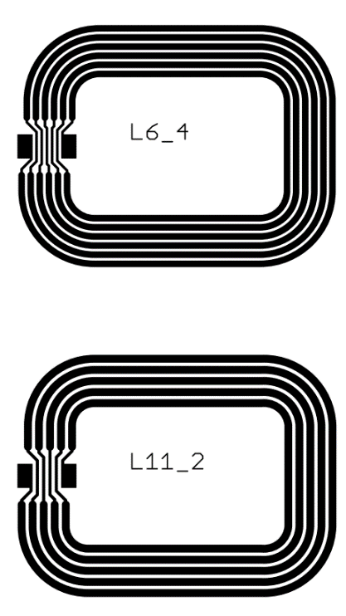

**Figure 3.** L6 design of the HF RFID antenna with 6 number of coils for the resonance frequency of 13.56 MHz with 2 bond pads

3. Results and discussions

3.1 Resistivity analysis

In order to manufacture smart electronic applications, printed tracks of silver nanoparticle ink must possess minimum electrical resistance on the paper substrates. The ink was printed considering the basic electrical element straight line on 17 different substrates as mentioned in Section 2.3.1. The electrical performance of the ink with all the substrates was recorded with 2WR digital multimeter to find the suitable ink-substrate combination which reveals the minimum resistance. The recorded resistances of all the ink-substrate combinations have been compiled in table 5. The surface roughness of the corresponding paper is also inserted for better correlation. This can provide the crucial information that if the resistance of the printed tracks are interrelated with the surface roughness of the papers. Also, good quality of printing was also observed, i.e., no overspray, wavy edges, etc.

Table 5. Overview of the surface roughness and resistance of the printed tracks of silver ink on all the paper substrates

|  |  |  |  |
| --- | --- | --- | --- |
| Supplier | Paper Name | Roughness Ra(nm) | Resistance R(Ω) |
| UPM | UPM Poste 100 | 2883,1 ± 270,1 | 34,6±6,5 |
| UPM | UPM Finesse Premium Silk H 115 | 812,9 ± 28,7 | 72,7± 5,95 |
| Stora Enso | BergaMail+ 100 | 3231,4 ± 466,7 | 221,6± 13,6 |
| Stora Enso | LumiSilk | 366,9 ± 51,2 | 34,2± 3,6 |
| Iggesund Paperboard | Incada Exel | 350,9 ± 74,6 | 42,5± 12,5 |
| Schoeller Technocell | p_e:smart paper type 2 | 114,2 ± 15,2 | 20,6± 0,9 |
| Papyrus | LuxoSatin | 424 ± 24 | 114,2± 24,55 |
| Grünperga | PG 70 | 714 ± 212 | 9,2± 5,4 |
| Grünperga | PG 90 | 555 ± 93 | 126,2±16,4 |
| Grünperga | *Coated PG 80 | 951± 24 | 26,4± 6.4 |
| Koehler Paper Group | Koehler Type A | 945 ± 36 | 6366,4 |
| Koehler Paper Group | Koehler Type B | 735 ± 57 | 4090,3 |
| Koehler Paper Group | *Coated Koehler Type B | 790 ± 10 | 2,4± 0,41 |
| Koehler Paper Group | *Coated Koehler Type E | 551 ± 9 | 368.5± 53,5 |
| Felix-Schoeller | Scholler 2 | 129 ± 20 | 18,6±8,4 |
| Sappi | Algo Baress | 404 ± 103 | 24,7±4,5 |
| Sappi | Parade Label A | 314,6 ± 65,7 | 1480,2 ± 44,2 |

*Coated with PVOH (polyvinyl alcohol) – done at IVLV, DE

According to Table 5, there is no correlation between the paper surface roughness and the sheet resistance values as also reported by [21]. In general, rough surfaces can cause discontinuation of the print and thus decrease the electrical conductivity. It is still recommended to use smooth surfaces in the field of printed electronics on paper substrates [8], [21], [48].

After re-recording the electrical resistance using a 2WR multimeter of the printed samples prepared for the stress tests, there is no major change in the electrical resistance before and after the stress tests. A negligible increase (in tens of mΩ) in resistance value was observed in a few cases which can be ignored. This is evidence that the sintered printed patterns can clearly withstand the stress performed over the chosen substrate without affecting the electrical performance of the printed pattern. The results recordings are not included in this paper as it will be intend for other study.

3.2 Limitations in paper selection

Curling and deformation of the antennas printed on the paper were observed when they were exposed to the curing step at high temperatures (>=150°C). It reflects the presence of moisture gradient across the surface from the warmest zone to the coolest zone to facilitate evaporation at the coolest surface. The variation of moisture content causes local shrinkage of fibre in this cooler zone, creating the curling effect towards this ‘lower’ temperature region of the substrate [49]. This issue was resolved by increasing the sintering time to 180 minutes with a reduction in the sintering temperature to ~120 °C. This new reduced temperature is still favorable for the successful sintering of the AgNPs ink. In Figure 4, clear curling, thermal degradation, delamination, and peeling of printed tracks were observed in some of the paper substrates. It undoubtedly reveals the lack of adhesion of the ink on the paper substrates which leads to the delamination of the printed ink after the thermal sintering process. Furthermore, crack formulation can be seen which facilitates failure of any printed pattern because of no conductivity across the printed pattern. Some of the smooth papers were eliminated despite being smooth due to delamination, adhesion issues, curling, and thermal degradation issues.

Due to this reason, paper substrates were discarded as the potential substrate for antenna printing and other applications. An alternative sintering process like NIR (Near InfraRed) can be used as it can sinter in less time which reduces the printed sample temperature; thus avoiding thermal degradation [50].

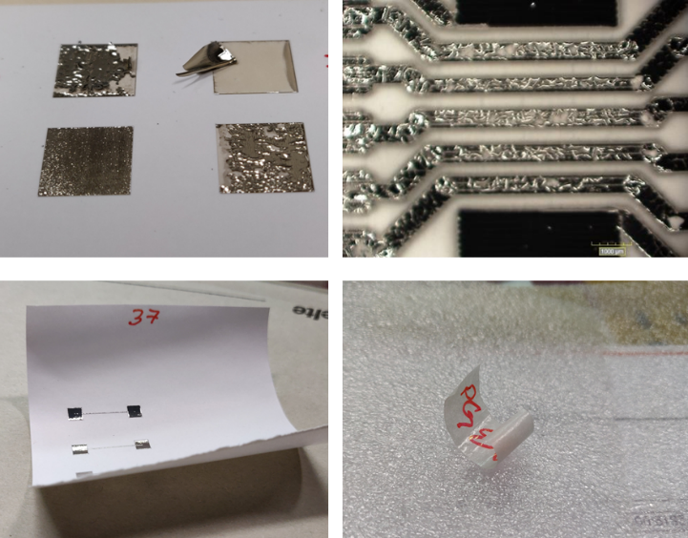**Figure 4**. Curling, thermal degradation and peeling of printed tracks observed upon different set of fibre-based substrates.

3.3 Ink-substrate interaction-cross-section inspection

Based on the results of the electrical performance of the interconnects printed in the previous step (3.1 & 3.2), a preselection could be made and 9 out 17 papers were put forward for deeper analyses and testing. These are listed as follows: Lumisilk, Incada Excel, Parade Label A, p_e: smart paper type 2, PG70, PVOH coated PG80, Koehler Type A, B (coated and uncoated).

Now, a cross-section analysis of the sintered ink on selected 9 different papers was performed by using optical microscopy as explained in Section 2.3.2.

Figure 4 (a) & (b) shows the thickness of the four printed layers on different papers. From Figure 4(a), interruptions/ cracks of the printed silver ink on Incada Excel paper can be distinctly observed. This adhesion issue can be due to the absence of the PVOH coating which is present in the Koehler type B. As visible optically, Incada Excel top surface is not homogenous despite having “relatively low” Ra macroscopically (350,9 ± 74,6 nm) than Koehler Type B (622± 9 nm). With coating, a uniformly homogenous can be achieved which results in crack-free sintered printed pattern [21], [48]. It also has good adhesion, film-forming ability, insulation, oil resistance, abrasion resistance, and gas barrier properties. In this case, the layer thickness of 4 printed layers of silver ink is 13.59 ± 0.66 µm whereas in Figure 4 (b) good quality of deposited ink on coated Koehler Type B can be observed with the layer thickness of 8.20 ± 0.18 µm.

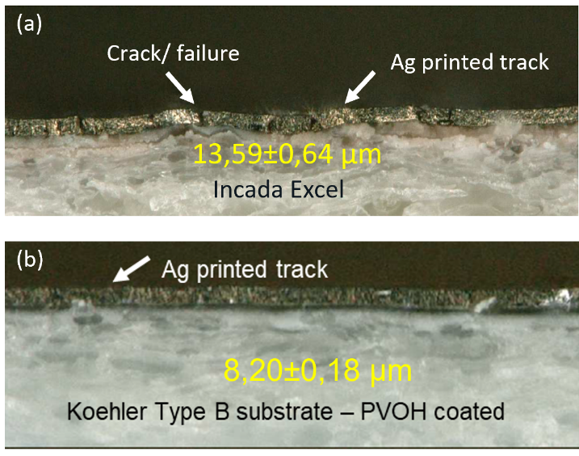

**Figure 5**. A cross-section of the sintered printed ink on different papers using optical microscope (a) Incada Excel paper as a substrate (Koehler Type B (coated) paper as a substrate).

Such inspections for the integrity of the printed lines are critical and plays a role in the designing and manufacturing of a flexible smart printed application on a paper substrate. A compromised line continuity is indeed responsible for limited functionality (conductivity) of the structures and/or failure.

Considering all the factors mentioned above like curling behavior, thermal degradation by sintering, mechanical stiffness or bending, etc., Koehler Type B (coated) was chosen further for the antenna production due to its smoothness, providing good quality printing without cracks or delamination, able to withstand thermal sintering, and lastly providing low electrical resistance to the silver line which was printed on top of them. Also, this paper was chosen not on the basis of the elimination method but instead the best performing in the above-mentioned properties. This paper substrates suffice all the desired properties needed to print an RFID antenna and outperforms the other papers considering Aerosol Jet® Printing. It shall be mentioned that this does not conclude that other papers with different properties are not relevant for printed electronics applications. They can be used with other various printing processes like screen or gravure printing and so on for any other applications.

3.4 Case studies discussion

3.4.1 Aerosol Jet® Printing of RFID Antenna

As mentioned in Section 2.4.1, a RFID antenna with the resonating frequency of 13.56 MHz was fabricated on a fibre-based paper substrate for smart packaging applications.

The antenna design was printed with the same nano silver ink on the fibre-based substrate Koehler Type B (coated). For ink-paper combinations, 5 samples of antennas were printed and validated extensively using RFID tags to mitigate errors in functionality testing and data recording. As visible in Figure 7, optical images of the printed silver tracks for antenna can be seen. The optical images reveals “good-quality printing” as there are no short circuits, delamination, overspray or cracks present/ visible. In the printed electronics applications such as antenna, a short circuit (by adjoining two different printed tracks) can lead to the failure in the functionality of the antenna. The printing parameters were similar as mentioned above in Table 2. The only change was made in the number of layers, instead of 10, 3 layers were printed to reach pre-requisite value, i.e. <~50 Ω. The sintering temperature was reduced to 110 °C for more than 180 minutes to avoid thermal degradation of the paper substrates.

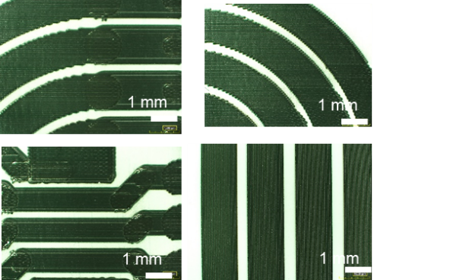

Figure 7: Microscopic images of an Aerosol Jet® Printed antenna on a paper substrate (Koehler Type B (coated)) using Metalon® JS-A221AE silver ink.

As per the pre-requisite for the fully functional antenna i.e. longest resistance path (from bond pad to bond pad) should be less than 50Ω and the inductance can be in between a range of 1 and 3 µH, the resistance of the printed antenna along its longest path length was 27 Ω using the 2WR multi-meter and the inductance measured was 2.57 µH. The frequency response of the printed antenna is provided in the following Figure 8.

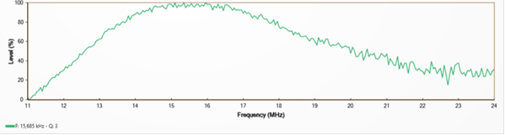

**Figure 8.** Frequency response curve of a functional antenna, verified by 5 different RFID Tag Codes

It can be seen from figure 8, that the antenna is having a right shift in the resonating frequency. The resonating frequency for this antenna refers to 14.130 MHz. Such slight shifting of the frequency response is acceptable and be explained by the higher resistance of the printed tracks of the antenna which consequently leads to a wider bandwidth. The increase in the bandwidth also spreads out the power of the antenna, which leads to the lowering of the absolute power level. It also reveals that the value of the electrical resistance varies in the printed antenna due to the printing variability of the AJ®P; the resonating frequency shifts to the higher frequencies. The lowest electrical resistance of the printed antenna resonates close to the RFID range whereas the antenna having the maximum electrical resistance is most deviated from the RFID resonating frequency.

The results of the other printed samples are compiled below in Table 6. RFID tags (designed, manufactured, and implemented in collaboration with IMEC, Quad Industries, and Roartis, Belgium) codes were used to read the printed antenna along with the 5 printed antennas presented with their electrical resistance and inductance values. 3 responses were recorded. “Y” refers to the successful reading and activation of the tag with the antenna, i.e. favorable electrical properties, ranging in the correct working frequency of the thin-film microchip and therefore, each code of tags could be properly extracted with the reader. Whereas “N” stands for no communication of the antenna with the RFID tags and there was no activation of the tag. This occurs either due to the failure in the continuous printed tracks of the antenna or mechanical deformation of the sample due to handling. “?” refers to the variable code and the reason for that is power transfer among the tag and antenna is enough to activate the tag but not reliable for the operation.

Table 6. Compilation of all the printed antenna responses with the RFID tags

|  |  |  |  |  |  |  |  |  |
| --- | --- | --- | --- | --- | --- | --- | --- | --- |
| # | L (µH) | R (Ω) | fres (MHz) | RFID TAGS CODE | | | |  |
|  |  |  |  | 6F0D | F70D | FD0D | FE0D | 3F0D |
| # 1 | 2.57 | 27 | 14.130 | Y | Y | Y | Y | Y |
| # 2 | 2.56 | 41 | 14.200 | Y | Y | Y | Y | Y |
| # 3 | 2.47 | 90 | 14.970 | Y | Y | Y | Y | Y |
| # 4 | 2.73 | 116 | 15.685 | ? | ? | ? | ? | ? |
| # 5 | - | - | - | N | N | N | N | N |

5. Conclusions

In this paper, 17 different (un)-coated fibre-based substrates were studied regarding printability and ink compatibility for printed electronics. Low values for both surface roughness Ra (1500 nm) and resistance (<50 Ω) showed promising for printed electronics on fibre-based substrates using a conductive silver nanoparticle (AgNPs) ink (in accordance of previous study [21]). In addition, mechanical and visual characteristics, along with the ability to withstand thermal sintering temperature were also considered to choose the appropriate paper for our application. Finally, the Koehler Type B (coated) substrate was chosen as it outperforms the other paper substrates.

Aerosol Jet® Printing was used to print HF RFID antenna on Koehler Type B (coated) paper with AgNPs Metalon® JS-A221AE ink. Out of the 5 printed antenna samples, the lowest series resistance and inductance of 27 Ω and 2.57 ± 0.01 µH, respectively were recorded with a resonating frequency (Fres) of 14.130 MHz. Due to these electrical characteristics, it was possible to extract the tags’ code of this ink-paper combination and was concluded to be successful for AJ® printing HF RFID antennas on paper substrates.

It can be concluded that Aerosol Jet Printing has been showcased to be a prototyping/ fabricating technique for printing antennas on a fiber-based substrate for the smart packaging industry.

Author Contributions

“Conceptualization, A.V., M.B., W.D., and E.F.; methodology, A.V., R.A.; validation, A.V. and R.A.; investigation, A.V., M.G., and L.T.; writing—original draft preparation, A.V.; writing—review and editing, R.A., M.G.; L.T., M.B., W.D., and E.F.; project administration, M.B., W.D. and E.F.; funding acquisition, M.B., W.D. and E.F. All authors have read and agreed to the published version of the manuscript.”

Funding

This study is part of the CORNET project ‘PAPERONICS: Low cost multisensory paper and packaging applications’ (2019–2021). This research was funded by Agentschap Innoveren en Ondernemen, Belgium (VLAIO), grant number HBC.2018.0225, and by Arbeitsgemeinschaft industrieller Forschungsvereinigungen “Otto von Guericke” e.V.) (AiF), grant number IGF-Vorhaben Nr.: 242 EBG. The APC was funded by KU Leuven, Belgium.

Acknowledgements

The authors gratefully acknowledge the financial and technical support of the 34 industrial partners of the PAPERONICS project consortium, in particular FETRA vzw (Brussels, Belgium). The paper substrates were kindly provided by DS Smith (Gent, Belgium), Elep (Lommel, Belgium), FETRA, Grünperga (Grünhainichen, Germany), IDTechEx (Germany), Koehler Paper Group (Oberkirch, Germany), Labeltech (IJsselstein, The Netherlands), Schoeller Technocell (Osnabrück, Germany) and Smurfit Kappa (Oosterhout, The Netherlands). The RFID integration on a label was kindly provided by QUAD Industries (Sint-Niklaas, Belgium) using the adhesive of Roartis (Genk, Belgium). Ardent thanks to Klaus Dieter Bauer -Fraunhofer IVV (Germany) for providing PVOH-coated samples.

References

[1] S. Kim, A. Georgiadis, and M. M. Tentzeris, “Design of inkjet-printed RFID-based sensor on paper: Single-and dual-tag sensor topologies,” *Sensors (Switzerland)*, vol. 18, no. 6, p. 1958, Jun. 2018.

[2] L. Pereira *et al.*, “Printable cellulose-based electroconductive composites for sensing elements in paper electronics Smart fabric sensors and e-textile technologies: a review Lina M Castano and Alison B Flatau-Recent citations Printable cellulose-based electroconductive composites for sensing elements in paper electronics,” *Flex. Print. Electron*, vol. 2, p. 14006, 2017.

[3] E. Smits *et al.*, “Development of printed RFID sensor tags for smart food packaging,” 2012.

[4] J. Liu *et al.*, “Future paper based printed circuit boards for green electronics: fabrication and life cycle assessment †,” 2014.

[5] G. Grau, R. Kitsomboonloha, S. L. Swisher, H. Kang, and V. Subramanian, “Printed transistors on paper: Towards smart consumer product packaging,” *Adv. Funct. Mater.*, vol. 24, no. 32, pp. 5067–5074, Aug. 2014.

[6] L. K. Wood *et al.*, “Paper Substrates and Inks for Printed Electronics.”

[7] F. Hoeng, A. Denneulin, and J. Bras, “Use of nanocellulose in printed electronics: a review,” *Nanoscale Rev. Cite this Nanoscale*, vol. 8, p. 13131, 2016.

[8] D. Tobjörk and R. Österbacka, “Paper electronics,” *Advanced Materials*, vol. 23, no. 17. pp. 1935–1961, 03-May-2011.

[9] M. Serpelloni, E. Cantù, M. Borghetti, and E. Sardini, “Printed Smart Devices on Cellulose-Based Materials by means of Aerosol-Jet Printing and Photonic Curing,” *Sensors*, vol. 20, no. 3, p. 841, Feb. 2020.

[10] H. Zhou, S. Li, S. Chen, Q. Zhang, W. Liu, and X. Guo, “Enabling Low Cost Flexible Smart Packaging System with Internet-of-Things Connectivity via Flexible Hybrid Integration of Silicon RFID Chip and Printed Polymer Sensors,” *IEEE Sens. J.*, vol. 20, no. 9, pp. 5004–5011, May 2020.

[11] K. B. Biji, C. N. Ravishankar, C. O. Mohan, and T. K. Srinivasa Gopal, “Smart packaging systems for food applications: a review,” *Journal of Food Science and Technology*, vol. 52, no. 10. pp. 6125–6135, 2015.

[12] M. Vanderroost, P. Ragaert, F. Devlieghere, and B. De Meulenaer, “Intelligent food packaging: The next generation.”

[13] J. P. Kerry, M. N. O’Grady, and S. A. Hogan, “Past, current and potential utilisation of active and intelligent packaging systems for meat and muscle-based products: A review,” *Meat Sci.*, vol. 74, no. 1, pp. 113–130, Sep. 2006.

[14] D. McFarlane and Y. Sheffi, “The Impact of Automatic Identification on Supply Chain Operations,” *Int. J. Logist. Manag.*, vol. 14, no. 1, pp. 1–17, Jan. 2003.

[15] P. Kumar, H. W. Reinitz, J. Simunovic, K. P. Sandeep, and P. D. Franzon, “Overview of RFID technology and its applications in the food industry,” *J. Food Sci.*, vol. 74, no. 8, pp. R101–R106, 2009.

[16] K. Finkenzeller, *RFID handbook: fundamentals and applications in contactless smart cards, radio frequency identification and near-field communication*. John wiley & sons, 2010.

[17] J. Machiels, A. Verma, R. Appeltans, M. Buntinx, E. Ferraris, and W. Deferme, “Printed Electronics (PE) As An enabling Technology To Realize Flexible Mass Customized Smart Applications,” *Procedia CIRP*, vol. 96, pp. 115–120, 2021.

[18] Y. Lin, D. Gritsenko, Q. Liu, X. Lu, and J. Xu, “Recent Advancements in Functionalized Paper-Based Electronics,” 2016.

[19] H. Shamkhalichenar and J.-W. Choi, “An inkjet-printed non-enzymatic hydrogen peroxide sensor on paper,” *J. Electrochem. Soc.*, vol. 164, no. 5, p. B3101, 2017.

[20] A. M. Mansour, N. Shehata, B. M. Hamza, and M. R. M. Rizk, “Efficient design of flexible and low cost paper-based inkjet-printed antenna,” *Int. J. Antennas Propag.*, vol. 2015, 2015.

[21] J. Machiels *et al.*, “Screen Printed Antennas on Fiber-Based Substrates for Sustainable HF RFID Assisted E-Fulfilment Smart Packaging,” *Materials (Basel).*, vol. 14, no. 19, p. 5500, 2021.

[22] G. Nyström, A. Razaq, M. Strømme, L. Nyholm, and A. Mihranyan, “Ultrafast all-polymer paper-based batteries,” *Nano Lett.*, vol. 9, no. 10, pp. 3635–3639, Oct. 2009.

[23] K. Y. Mitra, M. Polomoshnov, C. Martínez-Domingo, D. Mitra, E. Ramon, and R. R. Baumann, “Fully Inkjet-Printed Thin-Film Transistor Array Manufactured on Paper Substrate for Cheap Electronic Applications,” *Adv. Electron. Mater.*, vol. 3, no. 12, p. 1700275, Dec. 2017.

[24] J. Shen, L. Xie, J. Mao, and L. Zheng, “A passive UHF-RFID tag with inkjet-printed electrochromic paper display,” in *2013 IEEE International Conference on RFID, RFID 2013*, 2013, pp. 118–123.

[25] A. Vicente *et al.*, “Solar cells for self-sustainable intelligent packaging,” *J. Mater. Chem. A*, vol. 3, no. 25, pp. 13226–13236, 2015.

[26] S. Kim, “Inkjet-Printed Electronics on Paper for RF Identification (RFID) and Sensing,” *Electronics*, vol. 9, no. 10, p. 1636, Oct. 2020.

[27] V. Lakafosis, A. Rida, R. Vyas, L. Yang, S. Nikolaou, and M. M. Tentzeris, “Progress towards the first wireless sensor networks consisting of inkjet-printed, paper-based RFID-enabled sensor tags,” *Proc. IEEE*, vol. 98, no. 9, pp. 1601–1609, 2010.

[28] A. Rida, Li Yang, R. Vyas, and M. M. Tentzeris, “Conductive Inkjet-Printed Antennas on Flexible Low-Cost Paper-Based Substrates for RFID and WSN Applications,” *IEEE Antennas Propag. Mag.*, vol. 51, no. 3, pp. 13–23, Jun. 2009.

[29] A. Pereira *et al.*, “Near-field communication tag development on a paper substrate—application to cold chain monitoring,” *Flex. Print. Electron.*, vol. 3, no. 1, p. 14003, 2018.

[30] X. Li, J. Sidén, H. Andersson, and T. Schön, “A paper-based screen printed HF RFID reader antenna system,” *IEEE J. Radio Freq. Identif.*, vol. 2, no. 3, pp. 118–126, 2018.

[31] K. Janeczek, M. Jakubowska, A. Młożniak, and G. Kozioł, “Thermal characterization of screen printed conductive pastes for RFID antennas,” *Mater. Sci. Eng. B*, vol. 177, no. 15, pp. 1336–1342, 2012.

[32] K. Jaakkola *et al.*, “Screen-printed and spray coated graphene-based RFID transponders,” *2D Mater.*, vol. 7, no. 1, p. 15019, 2019.

[33] A. Vena *et al.*, “Design of Chipless RFID Tags Printed on Paper by Flexography,” *IEEE Trans. Antennas Propag.*, vol. 61, no. 12, pp. 5868–5877, 2013.

[34] I. Kharrat, G. Eymin Petot Tourtollet, J.-M. Duchamp, P. Benech, P. Xavier, and T.-P. Vuong, “Design and realization of printed on paper antennas,” in *2013 7th European Conference on Antennas and Propagation (EuCAP)*, 2013, pp. 3199–3202.

[35] H. Kang *et al.*, “Fully Roll-to-Roll Gravure Printable Wireless (13.56 MHz) Sensor-Signage Tags for Smart Packaging,” *Sci. Rep.*, vol. 4, no. 1, p. 5387, 2014.

[36] B. Xu *et al.*, “Aerosol jet printing on radio frequency identification tag applications,” *Key Eng. Mater.*, vol. 562–565, pp. 1417–1421, 2013.

[37] J. M. Hoey, A. Lutfurakhmanov, D. L. Schulz, and I. S. Akhatov, “A Review on Aerosol-Based Direct-Write and Its Applications for Microelectronics,” *J. Nanotechnol.*, vol. 2012, pp. 1–22, 2012.

[38] N. J. Wilkinson, M. A. A. Smith, R. W. Kay, and R. A. Harris, “A review of aerosol jet printing—a non-traditional hybrid process for micro-manufacturing,” *Int. J. Adv. Manuf. Technol.*, 2019.

[39] E. B. Secor, “Principles of aerosol jet printing,” *Flex. Print. Electron.*, vol. 3, no. 3, p. 035002, Sep. 2018.

[40] M. Smith, Y. S. Choi, C. Boughey, and S. Kar-narayan, “Controlling and assessing the quality of aerosol jet printed features for large area and flexible electronics Controlling and assessing the quality of aerosol jet printed features for large area and fl exible electronics,” *Flex. Print. Electron.*, vol. 2, p. 015004, 2017.

[41] A. Mahajan, C. D. Frisbie, and L. F. Francis, “Optimization of Aerosol Jet Printing for High-Resolution, High-Aspect Ratio Silver Lines,” *ACS Appl. Mater. Interfaces*, vol. 5, no. 11, pp. 4856–4864, Jun. 2013.

[42] R. Gibney, S. Matthyssen, J. Patterson, E. Ferraris, and N. Zakaria, “The human cornea as a model tissue for additive biomanufacturing: a review,” *Procedia CIRP*, vol. 65, pp. 56–63, 2017.

[43] R. Gibney, J. Patterson, and E. Ferraris, “High-Resolution Bioprinting of Recombinant Human Collagen Type III,” *Polymers* , vol. 13, no. 17. 2021.

[44] A. Verma, R. Goos, J. D. Weerdt, P. Pelgrims, and E. Ferraris, “Design, Fabrication, and Testing of a Fully 3D-Printed Pressure Sensor Using a Hybrid Printing Approach,” *Sensors*, vol. 22, no. 19. 2022.

[45] M. Seiti, P. S. Ginestra, A. Verma, E. Ceretti, and E. Ferraris, “Aerosol Jet® Printing on stereolithography resin substrates for in-vitro dual bioreactor sensing,” *Procedia CIRP*, vol. 110, pp. 174–179, 2022.

[46] M. Seiti, P. Ginestra, R. M. Ferraro, E. Ceretti, and E. Ferraris, “Nebulized jet-based printing of bio-electrical scaffolds for neural tissue engineering: a feasibility study,” *Biofabrication*, vol. 12, no. 2, p. 25024, 2020.

[47] M. Hedges and A. B. Marin, “3D Aerosol Jet® Printing - Adding Electronics Functionality to RP/RM,” *WHITEPAPER - Optomec*, pp. 14–15, 2012.

[48] P. Ihalainen, A. Määttänen, J. Järnström, D. Tobjörk, R. Österbacka, and J. Peltonen, “Influence of Surface Properties of Coated Papers on Printed Electronics,” *Ind. Eng. Chem. Res.*, vol. 51, no. 17, pp. 6025–6036, May 2012.

[49] S. Lee and G. H. Yoon, “Moisture transport in paper passing through the fuser nip of a laser printer,” *Cellulose*, vol. 24, no. 8, pp. 3489–3501, Aug. 2017.

[50] D. Reenaers, W. Marchal, I. Biesmans, P. Nivelle, J. D’Haen, and W. Deferme, “Layer Morphology and Ink Compatibility of Silver Nanoparticle Inkjet Inks for Near-Infrared Sintering,” *Nanomaterials*, vol. 10, no. 5. 2020.

**Design, fabrication and testing of a fully printed pressure sensor using hybrid printing techniques**

**Abstract:** Pressure sensor is not a new concept and is already exploited with different transduction mechanisms with different manufacturing techniques including Printed Electronics. But very limited efforts have been taken to fully print it using Additive Manufacturing techniques especially for personalized guides prosthetics in bio-medical applications. In this work, we present a novel fully printed piezo-resistive pressure sensor using Aerosol Jet Printing (AJP) along with Streolithography and Screen Printing. AJP was chosen to print silver ink as an base interconnects layer on a SLS printed polyamide board. Piezo-resistive ink was manually screen printed as a top sensing layer. The sensor was mainly mechanically tested on its response upon application of force in terms of hysteresis, time drift, cyclic tests and so on. With application of constant ramping pressure, sensor shows two different sensitive regions: highly sensitive from 0 to 0.1 MPa and low sensitive region which ranges from 0.1 to 1.25 MPa. Negligible hysteresis was observed and around 14% of change of resistance was observed in time drift testing. Such performances will suffice the demands of our application in bio-medical applications as a guides in prosthetics field.

**Keywords:***Aerosol Jet® Printing, Screen Printing, Piezo-resistive, Pressure sensor, Biomedical*

**1****. Introduction**

In this modern world, we live in an ecosystem of sensors of multiple forms and for various purpose. Physical sensors (mechanical, force, tactile, temperature, humidity,…), chemical sensors (liquid, gas, pH,…), biological sensors (cell based, bio-molecule based, microbial, …) are just some examples [1], [2].

There are several traditional ways to manufacture sensors using lithographic processes along with special coatings like electroplating, or lamination techniques, etc. [3]–[7]. Despite small and compact size of the components, there exist some drawbacks like large number of processing manufacturing steps and high cost of the equipment, which can be recuperated by mass production only [4], [8]. Printed Electronics (PE) is an emerging field to print electronics, with a reduced prototyping cost and a shorter time to market, providing form-factor while maintaining high accuracy and performance. More specifically, PE is an umbrella of techniques that involve printing or deposition of a functional material over a substrate, offering the possibility to produce devices that are thin, flexible, lightweight, cost-efficient, and environmentally friendly [9]–[11]. It is a technological area which involve multiple disciplines and expertise, from electronics, to manufacturing engineering, material science, chemistry, physics and biology. PE first use dates back to 1950 [12]. Nowadays, it proves its ability in multiple industries with applications as switches, sensors (pressure, strain, …) [13]–[15]; thin-film transistors (TFT) [16] antennas and RFID tags [17], energy harvesting and storage (organic solar cells and batteries) [18], displays (OLEDs) [19], and so on.

PE techniques are typically divided into direct and indirect methods. Indirect printing makes use of a mask or a screen to selectively deposit the functional ink on the target substrate. It suffers from a limited design versatility, but can serve large batch production purposes. Roll to roll printing, flexographic printing, gravure printing, screen printing are common examples. On the contrary, direct printing makes use of no mask and deposits the functional inks directly on the substrate through a nozzle according to a designed pattern. These techniques also named mask-less methods. They provide extended design and prototype flexibility [13]. Inkjet printing or Aerosol Jet**®** Printing (AJ®P) are the most common ones, with AJ®P getting an increasing attention in the recent years, due to its unique capabilities.

Aerosol Jet**®** Printing (AJ®P) was firstly commercialized by Optomec® at the beginning of the 21st century for the purpose of printed electronics applications. It can print microscale features (down to 10 m in plane resolution) with nanometric thickness (100 nm to several mm); theoretically, on whatever substrates (rigid, flexible, flat, curved, fibre-based, etc..) and with a large variety of functional inks, including metal and polymer nano-dispersion, biological fluids and water-based solutions, whose viscosity can vary in the range of 1-1000 mPa.s. Typical applications are antennas, RFID, interconnects, 3D electrodes, LED, photovoltaics and more recently also electrical and (bio-) chemical sensors with significant industrial and societal impact [20], [21]. AJ®P range from traditional printed electronics (PE) applications to advanced bioelectronics devices and 3D microscale printing. The use of AJ®P of collagen for tissue engineering applications is also a novel applications.

Screen printing (SP) is a direct contact printing technique transferring ink onto a substrate (e.g. paper, glass, plastics, fabrics, etc.) by using a mesh screen with apertures. The open meshes result in the appropriate stencil or printing image while the impermeable coating of the surrounding area blocks the ink deposition [12]. This printing technique uses high viscous (100-100000 mPa.s), thixotropic (shear thinning) inks resulting in a rectangular cross-sectional morphology of the printed pattern [13]. A broad range of functional materials can be deposited, such as metal inks (Ag, Cu, etc.), polymeric inks (e.g. PEDOT:PSS), carbon-based inks, dielectrics… When applying an ink onto a substrate, the squeegee (rubber blade) is moved across the screen, thereby filling the mesh openings with ink. In this forward movement, the screen is momentarily forced to the substrate and the ink is deposited by capillary forces. The blade finally scrapes the ink excess to its initial position and the printing process can be repeated several times to print multiple layers. The maximum printing resolution is tens of microns and the layer thickness of one pass ranges from a few μm to 100 μm, depending on the screen’s mesh size. The main SP parameters include the screen dimensions (e.g. mesh size, mesh thickness…), the printing speed, the squeegee pressure and - hardness, as well as the snap-off distance [14]. In addition, rotary SP can significantly increase the printing speed (> 100 m/min) using a stationary positioned squeegee placed inside a cylindrical screen that rotates at the same rate as the web. This SP method is suitable for large-scale production because of its reliability, but on the other hand it is more expensive and challenging to set up [15].

In this work, we use AJ®P to develop a fully printed pressure sensor applied on an additive manufactured and customized substrate to realize patient specific biomedical solutions. The sensing principle is piezo-resistive, owing to its simple read-out, easy to implement and good performance [22]. The sensor was designed, manufactured and characterized with respect to sensitivity, hysteresis, repeatability and time drift. It can be applied as force detector and/or guiding tool in prosthetics joints or personalized surgical guides. The substrate used for this sensor is produced by Additive Manufacturing (AM) - Selective Laser Sintering (SLS) technique. AJ**®**P was specifically chosen because of its ability to print on free-form substrates and design flexibility. The use of AJ®P was accompanied by screen printing to deposit the sensitive layers due to the lack of piezo-resistive commercial solutions for AJ**®**P. Hence, the work also shed light on limitations and capabilities of the Aerosol Jet technique next to the sensor findings. From author’s knowledge, there is no literature report with usage of Aerosol Jet**®** Printing in the fabrication of a fully printed pressure sensor. This work reports the novel combination of a PE (AJP +SP) and AM (SLS) for a fully printed (AM+PE) pressure sensor.

**2. Background on printed sensors**

According to Narakathu et al. [23], conventionally made silicon pressure sensors are often expensive, produced on a rigid substrate, and lack the properties required for various sensing applications. To overcome these problems, sensors can be fabricated using PE techniques which are thin, lightweight, flexible, and cost-efficient.

In the field of printed electronics, the major pressure sensor types are piezoresistive-based, capacitive-based, piezoelectric-based, and triboelectric-based sensors, which all have different working principles as illustrated in the Figure 1 and more details are mentioned in [24]. In Table 1, few previous works of the printed sensors are compiled in terms of key materials, printing method, working principle and measurement range and values. Every sensor manufacturing, material selection and the measurement range are varied and depends on to the corresponding application.

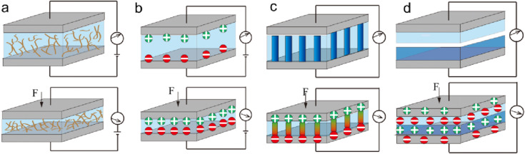

**Figure 1.** Four major transduction mechanisms – (a) piezoresistive (b) capacitive (c) piezoelectric (d) triboelectric. Taken from [24].

|  |  |  |  |  |  |
| --- | --- | --- | --- | --- | --- |
| **Authors** | **Materials Used** | **Printing/**  **Production Method** | **Working Principle** | **Range values/**  **Output** | **Ref** |
| Polzinger | Conductive: Silver  Sensing: Polymer ink  UV curing insulator  Substrate: PBT | Inkjet  Aerosol Jet | Capacitive |  | [25] |
| Rajala | Conductive: Silver  Sensing: PVDF-TrFE  Top layer: Silver  Substrate: PET | Screen | Piezo-electric | Normal mode:2pC/N  Bend mode: 200 nC/N | [26] |
| Ramalingame | Conductive: Silver  Sensing: PDMS + MWCNTs  Substrate: Kapton | Inkjet | Piezo-resistive | Range: 2.5 to 640 kPa | [27] |
| Ahmad | Conductive: Silver  Sensing: Carbon black  Substrate: PET | Screen | Piezo-resistive | Range: 1 to 100 N | [28] |
| Wang | Conductive:  Sensing: Carbon+ silicon |  | Piezo-resistive | Range: 0-1 MPa | [29] |
| Park | PDMS, SWCNT, Air Gap | Spray coating. Mould | Capacitive | Sensitivity: 0.7 KPa-1 (for P<1 kPa) | [30] |
| Sun | Ionic materials | Hydro-gel preparation | Capacitive | Range: 10 to 40 kPa | [31] |

In this study, we will investigate the characteristics of piezoresistive-based sensors more in detail due to their ease to implement, high spatial resolution, simpler readout [24].

The performance of a sensor can be described by multiple parameters. Key sensor parameters such as hysteresis, sensitivity, repeatability, and temperature and humidity drift are discussed in Table 2.

**Table 2.** Key sensor parameters

|  |  |
| --- | --- |
| **Key sensor parameter** | **Discussion** |
| Hysteresis  [15], [32], [33] | This is the difference in output value between increasing and decreasing force.  Caused by the viscoelasticity of the piezoresistive ink and substrate.  Optimal: as low as possible. (expressed as %) |
| Sensitivity[33] | The sensor's sensitivity is a measure for the change of output value in function of a change of input.  In the case of a piezoresistive sensor, the input value is a force and the output value is a change in resistance. (Expressed as ΩPa-1) |
| Repeatability  [22], [33], [34] | This is the capability of the sensor to produce an equal response each time the same input is applied.  Optimal: As high as possible. |
| Stability  [15], [22], [33], [34] | This is the capability of the sensor to produce a constant output value when a constant force is applied over a period of time.  Change in stability is called drift of the sensor.  Optimal: stability as high as possible, drift as low as possible. |
| Temperature & humidity range  [22], [35] | When the environmental conditions (temperature and relative humidity) change, the characteristics of the sensor will be altered.  An operating range can be determined in which the sensor shows acceptable variation in output. |

*2.1. Piezo-resistive Sensors*

Piezoresistive sensors convert an applied pressure, as a result of a force, into a change of resistance. Piezoresistive materials are used to provide a change in resistance when a force is applied. According to Valle-Lopera et al. [15], the relationship between the applied force (F) and the resistance of the material can be described by:

$R=\frac{ρ∙K }{F},$ (1)

Where ρ is the resistivity and K is a function of the surface roughness and elastic properties of the material. As seen in the previous equation, the resistance of the piezoresistive material is inversely proportional to the applied force. The electrical resistance will be in the range of mega ohms when no force is applied and decrease when the applied force increases[15]. The piezoresistive layer is typically a conductive polymer, which is made by dispersing conductive nanoparticles into a non-conductive polymer matrix. According to Ramalingame et al. [33], polydimethylsiloxane (PDMS) is widely used as background for the piezoresistive layer, because of its flexibility, biocompatibility, and temperature stability. However, Kappassov et al. [36], reported that the use of elastic materials results in hysteresis in the piezoresistive layer and a decrease in sensitivity due to wear. They also report that the characteristics of the material can change according to temperature and moistness and that there is low repeatability after multiple deformations. According to Ramalingame et al. [33], the piezoresistive properties of the composite are dependent on the choice of nanoparticles used in the polymer matrix. Carbon nanotubes (CNT’s) are widely used as nano-fillers, with a concentration ranging from 1 wt% to 8 wt% and a pressure limit ranging from 5 kPa to 200 kPa.

Wang et al. [37], developed a pressure sensor where carbon black dispersed in a silicone rubber is used as a piezoresistive layer. Figure 2a shows the structure of this carbon black/ silicone rubber nanocomposite, where phase A is a rubber molecule chain, phase B is crosslinking between the rubber chains, phase C is a macro-rubber which is absorbed by the carbon black surface, and phase D is the carbon black nanoparticle. Phases C and D act as a framework, which is connected by elastic phases A and B which form the background of the material. When pressure is applied to the material, the gap between the carbon black particles decreases, resulting in the formation of local conductive paths. As showed in Figure 2b, an effective conductive path is formed where the local conductive path penetrates the outer insulating layer.

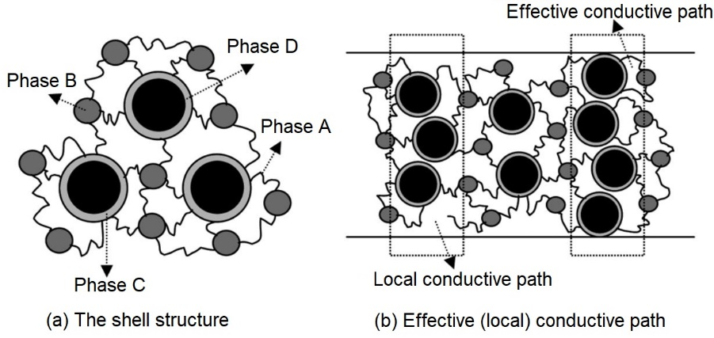

**Figure 2**. Schematic diagram for the shell structure (a) and the effective (local) conductive path (b) of a nanocomposite [38]

The conductive path is a result of the so-called, tunneling effect. This is the crossing of electrons between closely spaced nanomaterials, through the non-conductive barrier between them. According to Zhang et al. [39], the total resistance in a conductive polymer is determined by the combined resistance of the conductive particles and the polymer matrix. They report that the resistance of the paths perpendicular to the current flow can be neglected when assuming that the resistivity of the matrix is constant in the entire composite. This results in a relationship where the number of conductive particles between the electrodes, and the number of conductive paths influence the resistance, as seen in the following equation:

$R_{0}=\frac{\left(L-1\right)R_{m}+LR_{c}}{S}≈\frac{L\left(R_{m}+R_{c}\right)}{S},$ (2)

where R0 is the conductive polymer resistance, Rm the resistance between two neighboring filler particles, Rc the resistance across a conductive filler particle, L the number of particles forming the conductive path, and S the number of effective conductive paths. When the distance between the conductive filler particles is very large, no current flows through the particle gap. When the distance between the conductive particles decreases, a tunneling current flows from one particle to another through the polymer separation. According to Kalantri et al. [40], the tunneling current (J) at an applied voltage (V) can be expressed by the following equation:

$J=\frac{3\sqrt{2mφ}}{2s}∙{\left(\frac{e}{h}\right)}^{2}∙V∙exp\left(-\frac{4πs}{h}\sqrt{2mφ}\right),$ (3)

where m and e are electron mass and charge respectively, ϕ is a constant for the energy barrier of the polymer between two neighboring filler particles, h is Plank’s constant, and s is the distance between the nanoparticles.

Zhang et al. [39], reported a proportional relationship between the tunneling resistivity (Rm) and the contact area (a2) between two conducive filler particles. This leads to the following equation:

$R_{m}=\frac{V}{a^{2}J},$ (4)

Assuming that the distance between the particles decreases from s0 to s when pressure is applied, the relative resistance (R/R0) can be formulated by combining equation 2, 3, 4

|  |  |  |
| --- | --- | --- |
|  | $$\frac{R}{R_{0}}=\frac{s}{s_{0}}exp\left[-γ(s_{0}-s)\right]$$ | (5) |

where R0 is the initial resistance of the composite and s0 the initial distance between the conductive nanoparticles. The deformation of the conductive filler particles is in the range of a few nanometers and can be neglected compared to the deformation of the matrix. The distance between neighboring particles can thus be expressed as:

$s=s_{0}\left(1-ε\right)=s_{0}\left(1-\frac{σ}{E}\right)$ (6)

where ε is the strain of the polymer matrix. Wu et al. [41], reported that the initial distance between filler particles, which are spherical and arranged in a cubic lattice, can be determined by:

$s_{0}=D\left[{\left(\frac{π}{6ϑ}\right)}^{1/3}-1\right]$ (7)

where D is the conductive filler particle diameter and ϑ the volume fraction of the filler in the composite matrix. Substituting equation 6 and 7 in 5 results in:

$\frac{R}{R_{0}}=\left(1-\frac{σ}{E}\right)exp\left\{-γD\left[{\left(\frac{π}{6ϑ}\right)}^{\frac{1}{3}}-1\right]\frac{σ}{E}\right\}$ (8)

$\frac{R}{R_{0}}=f\left(σ,E,D,ϑ,φ\right)$ (9)

Looking at equation 9, we can conclude that the most important parameters affecting the relative resistance are: applied stress (σ), the elasticity modulus of the polymer matrix (E), the conductive filler diameter (D), the filler volume fraction (ϑ), and the constant for the energy barrier of the polymer (ϕ).

This section concludes the in-depth piezo-material based sensing layer transduction and following section introduces to the materials and methods used in this work.

**3. Materials and Methods**

*3.1. Inks and Substrates*

The substrate, which acts as a base for the sensor configuration of dimension 7x7 cm, and thickness of 1 cm, is a 3D (Selective Laser Sintering - SLS) printed polyamide (PA) board with a melting temperature ranging from 172 to 180 °C and an average roughness Ra of 6 μm and Rz of 31 µm. This substrate was produced by Materialise, Leuven, Belgium. Grinding and polishing of the substrate were done using 600 and 2400 grit paper to decrease the surface roughness and smoothen the top surface to avoid any defects.

Two types of ink were used for the production of sensors. The first type is a conductive silver ink (Metalon® JS A221E, Novacentrix. Inc.) which is used to print the conductive paths. The second type is piezo-resistive ink (Carbon EMS CI 2050, ECM) which is used to print the piezo resistive pressure elements. The properties of the inks are given in Table 3.

**Table 3.** Properties and details of the ink used

|  |  |  |
| --- | --- | --- |
| **Name** | **Metalon® JS A221E** | **Carbon EMS CI 2050** |
| Technique | Ultrasonic AJ®P | Screen printing |
| Type | Conductive silver ink | Piezoresistive carbon ink |
| Solid content | 40-60 wt% Ag | 31 wt% Carbon |
| Other content | 3-10 wt% 2,2-oxybisethanol  2-10 wt% isopropyl alcohol | / |
| Dynamic viscosity | 10-20 mPas | 2500 mPas |
| Average particle size | 35 nm | / |
| Appearance | Brown to grey | Black |
| Cure temperature and time | 150 °C for 120 mins | 150 °C for 30 mins |

*3.2 Sensor design, fabrication and testing*

A configuration of six sensors with different dimensions (100mm2 to 25mm2) is produced onto a single substrate. The range in sensor dimensions allows us to investigate the relationship between sensor size and piezoresistive behavior. The sensor circuit consists of Aerosol Jet® Printed silver lines which act as electrodes. The piezoresistive ink is screen printed between the electrodes and provides the active material, from which the resistance will change in function of the applied pressure. This sensor configuration is produced on a flat, printed polyamide (PA) substrate, as shown in Figure 3, where the sensors are also enumerated ranging from 1 to 6. This aids in the description of a certain sensor cell e.g. “sensor PA_1” has the biggest sensing area and is located in the upper left corner of the PA substrate. Three samples of the sensor configuration were made to increase the reliability of the experimental results and to mitigate the errors.

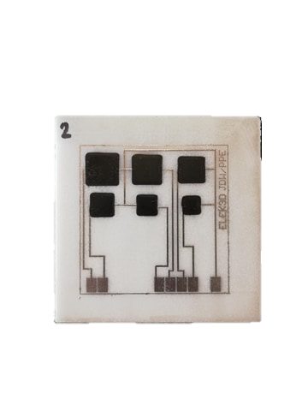

**1**

**2**

**3**

**4**

**5**

**6**

**Silver ink**

**Piezoresistive ink**

**PA substrate**

**Board 2**

**Figure 3.** Arrangement of 6 piezo-resistive pressure sensors printed on PA substrate, with a sensing area ranging from 100mm2 to 25mm2

The production process of the sensor board can be divided into multiple steps. First, the conductive lines are Aerosol Jet® printed onto the substrate, using the Metalon® JS A221E ink and the Optomec 300 series Aerosol Jet® printer. The atomization of ~1 ml ink was done using ultrasonic method. Nitrogen gas was used as inert gas to carry and collimate aerosol. 300 micron diameter of ceramic nozzle used for printing silver ink. The printing parameters are shown in Table 4. Next, the conductivity of the printed lines is improved by sintering themally in an oven at 150 °C for 2 hours.

On top of the sintered silver electrodes, the piezo-resistive pressure elements are screen printed-manually, using the Carbon EMS CI 2050 ink. According to the data from the ink supplier and experiments conducted on the PA substrate, an optimal ratio of 60wt% CI-2050HR: 40wt% CI-2050LR was found. This ratio will thus be used to produce the sensors onto the final PA substrate. The viscous ink was hand stirred for minimum 5 minutes. Two printing passes were done with a 30 μm thick stainless steel screen for uniformity and avoid unwanted gaps in the printed pattern. The screen and the squeegee was cleaned with MEK (ketone) solvent. The conductivity of the piezo-resistive pressure elements is improved by sintering in an oven at 150 °C for 30 mins. All steps of printing were performed at room temperature and relative humidity of ~ 50%.

**Table 4.** Printing parameters for Optomec 300 series

|  |  |
| --- | --- |
| Parameter | Value |
| Atomizer gas flow | 65 sccm |
| Sheath gas flow | 45 sccm |
| Printing speed | 7 mm/s |
| Table temperature | 23 °C |
| Number of layers | 7 |

*3.3. Equipment involved*

The Instron 3367 is a mechanical testing system that can perform high-quality tensile, compression, and bending tests. For this work, only the compression feature is performed. The Instron 2530-5 kN load cell is mounted onto the crossbeam of the Instron 3367 mechanical testing system. The load cell makes sure that the correct load is applied and monitored at all times. The load cell also allows us to zero out the tare weight of the compression head as discussed later. Before testing, the complete setup is also calibrated. During the measurement, the applied load is registered with a sampling rate of 50 Hz. The compression head is mounted onto the load cell and transfers the force, which is regulated by the load cell, to a pressure exerted onto the piezo-resistive material of the sensor.

The Weiss Technik Heraeus thermal oven is used to sinter the printed lines. By adjusting the temperature of the oven or altering the sintering time, different sintering conditions can be achieved.

The Hirox KH 8700 digital microscope is used to examine the printed lines. Using the low range resolution lens, an enlarged view of the printed lines can be studied to obtain critical information about the printing and sintering process. Using this tool, measurements can be made to determine the line width, which is especially interesting for the design of the sensor circuit, and to inspect the overall quality of the printed patterns before and after sintering (overspray, cracks, etc…)

A Rigol DM3068 digital multimeter is used to measure the change in resistance when the applied force is increased. 4-wire resistance measurement is preferred because of its higher accuracy, but because there is only a limited space to attach the probes onto the sensor, a 2-wire resistance measurement is conducted. After each measurement, the data are saved onto a removable drive. Because of the difference in sampling rate between the Instron 3367 (50 Hz) and the Rigol digital multimeter (2 Hz), the number of recorded force data is 25 times more than that of the change in resistance over the same period of time. A Matlab code is written to combine those two data sets, which can be consulted in supplementary materials.

*3.4 Mechanical Testing Conditions*

A ramping force test will be conducted where a force-cycle, 0-125-0 N, is applied to the sensors to determine which sensor size gives the highest change in resistance for a given amount of pressure. Comparing the change in resistance for increasing and decreasing force also gives information about the hysteresis of the sensors. Note that for each experiment, three measurements (repetitions) are conducted on each sensor of the three boards.

Next, a cyclic force test is conducted where the sensors are exposed to multiple pressure cycles, 0-125-0 N, to determine the repeatability of the sensors. Finally, a constant force test is conducted where a force of 125 N is applied over a period of time. This shows the stability of the sensor in function of the time, also known as time drift. Note that the cyclic and constant force experiments are conducted on sensor one (S1) of the three substrates, where three repetitions were done for each sensor. Between each of these repetitions, the sensor is given 30 mins time to reach again its initial condition. The conducted experiments along with the testing conditions are listed in Table 5.

**Table 5.** Conducted tests and testing conditions

|  |  |  |  |
| --- | --- | --- | --- |
|  | **Ramping force** | **Cyclic Force** | **Constant force** |
| Conducted on | S1-S6 | S1 | S1 |
| Min force (N) | 0 | 0 | 0 |
| Max force (N) | 125 | 125 | 125 |
| Compression rate (N/s) | 3 | 10 | 3 |
| # cycles (/) | / | 50 | / |
| Holding time (min) | / | / | 10 |

Compression testing is done on all sensor sizes, as seen in Figure 3a.The compression head is also equipped with a 1 mm thick rubber patch, which has the same dimensions as the compression head, as seen in Figure 3b. This compensates for alignment errors and provides an insulating layer between the conductive piezoresistive material and compression head. When using a rigid compression head, the smaller sensors are exposed to a higher pressure because the force is spread over a smaller area. Using a rubber insert between the rigid compression head and the piezoresistive material allows us to spread the applied force over the same area for each sensor. Since the piezoresistive material has a thickness of only 30µm, the rubber insert will deform under the applied force making contact with both substrate and piezoresistive material. This way the applied load is always distributed over the area of the rubber patch, resulting in an equal pressure for each experiment no matter the sensor dimensions. Vulcanized rubber is used as patch material because of its low hysteresis and high elastic properties. To increase the reliability of the results, three repetitions are performed per sensor. Figure 4c shows the whole setup of the mechanical testing along with resistance reading.

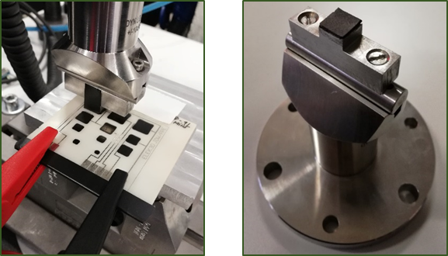` 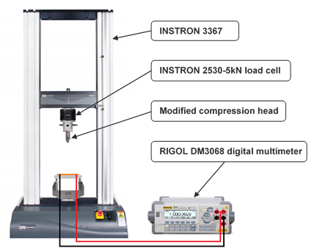

**c)**

**b)**

**a)**

**Figure 4.** (a) non-conductive tape and crocodile clamps; b) rubber patch on compression head; c) tensile testing test bench connected with a digital multi-meter.

**4. Results**

*4.1. Mechanical Testing - Ramping Force*

During the ramping force test, the force is increased from 0 to 125 N with a compression rate of 3 N/s. The change of resistance in function of the applied pressure for each of the sensor sizes, along with the combined data of all the boards together. The mean sensitivity and standard deviation for the three boards along with the mean sensitivity and standard deviation of all data combined in Figure 5.

**Table 6.** : Mean sensitivity and standard deviation for the two regions of sensitivity (low & high load)

|  |  |  |  |  |
| --- | --- | --- | --- | --- |
|  | **Region 1 (low load)** | | **Region 2 (high load)** | |
| Board | Mean sensitivity (Ω/MPa) | Std (Ω/MPa) | Mean sensitivity (Ω/MPa) | Std (Ω/MPa) |
| 1 | 120.52 | 47.06 | 6.18 | 0.74 |
| 2 | 113.52 | 26.86 | 7.57 | 1.01 |
| 3 | 106.60 | 16.83 | 6.39 | 0.33 |
| All | 117.63 | 17.61 | 6.39 | 0.49 |

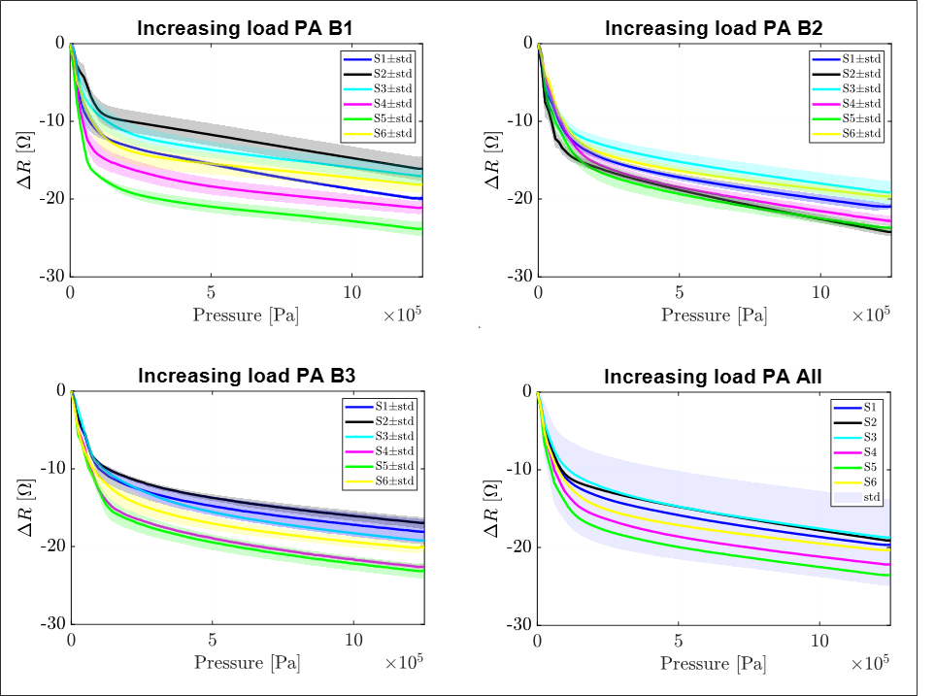

**Figure 5.** Increasing load *Vs.* change in resistance in function of pressure

*3.2. Hystersis*

During the hysteresis test, sensor one of each board is exposed to a loading and unloading cycle. First, the force is increased from 0 to 125 N with a compression rate of 3 N/s. Afterward, the force is decreased again from 125 to 0 N with a negative compression rate of -3 N/s. The change of resistance in function of the applied pressure is illustrated in Figure 6, along with the combined hysteresis data of sensor one for all boards combined.



**Figure 6.** Hysteresis *Vs.* change in resistance in function of pressure

*4.3. Time Drift Testing*

During the time drift test, sensor one of each board is exposed to a force that increases from 0 to 125 N with a compression rate of 3 N/s. Afterward, the force is kept constant at 125 N over a period of 600 s. The change of resistance in function of time is illustrated in Figure 7, along with the combined time drift data of sensor one for all boards combined. No longer time duration was needed due to the demand of our application.



**Figure 7.** Time drift *Vs.* change in resistance at 125N in function of time

*3.4 Cyclic Forces*

During the cyclic force test, sensor one of each board is exposed to 50 loading and unloading cycles where the load increases and decreases between 0 and 125 N at a compression rate of 10N/s. The change of resistance in function of the number of cycles is illustrated in Figure 8.



**Figure 8.** Cyclic force *Vs.* change in resistance in function of loading cycles

**5. Discussion**

When looking at the measurements, it reveals that the sensors have two regions of sensitivity, which are caused by the compressibility of the material. When pressure is applied, the composite layer gets compressed fast at first resulting in high sensitivity. When a certain threshold is reached, further compression of the composite layer decreases while the applied pressure is increased, resulting in a decrease in sensitivity. The first region ranges from 0-0.1 MPa and has a high sensitivity, while the second region ranges from 0.1-1.25 MPa and has a notable lower sensitivity. We can also see quite some difference in the total change of resistance for the different sensor sizes over the multiple boards (standard deviation), particularly for the high sensitivity region. According to the literature, this can be due to the fact that the amount of conductive filler particles can vary in the batch of prepared ink, resulting in different piezoresistive characteristics from batch to batch. On the other hand, there is no visible relationship between the dimensions of the sensor (contact area) and the change in electrical resistance.

When looking at the results of Table 6, we can conduct that the sensitivity in the first region is about 20 times higher than the sensitivity in the second region. The standard deviation of the sensitivity is also about 40 times higher in the first region than in the second region. From this, we can conduct that although the first region is the most sensitive, it is also more unpredictable than the second region which is less sensitive but more predictable. Since the mean sensitivity of both regions is more or less the same for all of the sensors on the three boards, we can conclude that the sensor size does not influence the sensitivity.

In the case of hysteresis measurements, change in resistance is higher during the loading cycle than during the unloading cycle. This phenomenon is called the hysteresis of the sensor and can be seen as the area between the loading and unloading cycle. From this we can conduct that the hysteresis is particularly present in the region of high sensitivity, although it is only in small amounts. This can be ignored due to the demands of the application for this sensor, which can be as a guide in prosthetics for bio-medical applications.

Time drift results reveal that the change in resistance decreases 13,16 ± 3,84 % over a period of 600 seconds. This is a rather high drift as compared to the literature where time drift values of 5 % are reported. During the time drift, relaxation of the composite occurs, resulting in better stability of the polymer matrix. This results in improved stability, as can be seen in Figure 7, where the change in resistance seems to a near-constant value. The reasons for such drift could be structural tension of the top surface after the application of force on sensing layer, the drift caused in the clamps while readout, or the non-uniform stress application which was tried to be mitigate using elastic rubber stamp on the head of the compression head [28].

Figure 8 also shows the combined cyclic data of sensor one for all boards combined. When looking at the results we can see that the change in resistance decreases 28,34±16,95% over a period of 50 cycles. This is a rather high change in resistance as compared to the literature where a change in resistance of 8% is reported under cyclic loading. During the cyclic loading, relaxation of the composite occurs, resulting in better stability of the polymer matrix. This so-called ‘mechanical training’ results in improved stability and repeatability of the sensor. Such improvement is visible at Figure 8 as the curve approaches constant value.

**6. Conclusions**

Piezoresistive pressure sensors were developed on flat PA substrate using the Optomec Aerosol Jet® Printer along with SLS printed substrate and a manual screen printing of a sensing layer. To get a better understanding of the characteristics of the sensor, compression testing was conducted on the Instron 3367 mechanical testing system, where the change in resistance was measured in function of the applied pressure. Experiments were conducted to investigate the sensitivity, hysteresis, time-drift, and repeatability of the sensors. From the results of these experiments, we can conclude that the piezoresistive sensors have a mode of high sensitivity and low reliability ranging from 0 to 0.1 MPa, where there also is a slight amount of hysteresis, opposed to a second mode with low sensitivity and high reliability which ranges from 0.1 to 1.25 MPa which suffices its demand for bio-medical applications. We can also conclude that the sensor size does not influence the sensitivity of the sensor and that the change in resistance decreases in function of both time and number of compression cycles. Furthermore, it is a novel fully printed pressure sensor as per author’s knowledge.

Such sensors can be also be used in future for posture recognition, with matrix of sensors. Not only that, it can extend its applications for in-sole pressure monitoring in shoes, or in mattress and in wheelchairs for patients with reduced mobility (pressure ulcer). Along with it, it can be implemented in the curved or free-form surfaces.

**Author Contributions:** For research articles with several authors, a short paragraph specifying their individual contributions must be provided. The following statements should be used “Conceptualization, X.X. and Y.Y.; methodology, X.X.; software, X.X.; validation, X.X., Y.Y. and Z.Z.; formal analysis, X.X.; investigation, X.X.; resources, X.X.; data curation, X.X.; writing—original draft preparation, X.X.; writing—review and editing, X.X.; visualization, X.X.; supervision, X.X.; project administration, X.X.; funding acquisition, Y.Y. All authors have read and agreed to the published version of the manuscript.” Please turn to the CRediT taxonomy for the term explanation. Authorship must be limited to those who have contributed substantially to the work reported.

**Funding:** This research was funded by VLAIO, as a part of the Project: TETRA 3D ElektroPrint, -3D printen van vrije vorm elektrische/elektronische toepasssingen -HBC.2016.0067.

**Acknowledgments:** In this section, you can acknowledge any support given which is not covered by the author contribution or funding sections. This may include administrative and technical support, or donations in kind (e.g., materials used for experiments).

**Conflicts of Interest:** The authors declare no conflict of interest.

References

[1] M. Cheng *et al.*, “An review of flexible force sensors for human health monitoring,” *J. Adv. Res.*, 2020.

[2] Y. Ni, R. Ji, K. Long, T. Bu, K. Chen, and S. Zhuang, “A review of 3D-printed sensors,” *Appl. Spectrosc. Rev.*, vol. 52, no. 7, pp. 623–652, 2017.

[3] A. Frutiger *et al.*, “Capacitive soft strain sensors via multicore–shell fiber printing,” *Adv. Mater.*, vol. 27, no. 15, pp. 2440–2446, 2015.

[4] P. Tseng, C. Murray, D. Kim, and D. Di Carlo, “Research highlights: printing the future of microfabrication,” *Lab Chip*, vol. 14, no. 9, pp. 1491–1495, 2014.

[5] S. Kasani, K. Curtin, and N. Wu, “A review of 2D and 3D plasmonic nanostructure array patterns: fabrication, light management and sensing applications,” *Nanophotonics*, vol. 8, no. 12, pp. 2065–2089, 2019.

[6] C. Da Vià, “3D sensors and micro-fabricated detector systems,” *Nucl. Instruments Methods Phys. Res. Sect. A Accel. Spectrometers, Detect. Assoc. Equip.*, vol. 765, pp. 151–154, 2014.

[7] R. Puers, “Capacitive sensors: when and how to use them,” *Sensors Actuators A Phys.*, vol. 37, pp. 93–105, 1993.

[8] P. F. O’Neill *et al.*, “Advances in three-dimensional rapid prototyping of microfluidic devices for biological applications,” *Biomicrofluidics*, vol. 8, no. 5, p. 52112, Oct. 2014.

[9] Y. Khan, A. Thielens, S. Muin, J. Ting, C. Baumbauer, and A. C. Arias, “A New Frontier of Printed Electronics: Flexible Hybrid Electronics,” *Advanced Materials*, vol. 32, no. 15. Wiley-VCH Verlag, 01-Apr-2020.

[10] S. Faraz Hasan, “SPRINGER BRIEFS IN ELEC TRICAL AND COMPUTER ENGINEERING Emerging Trends in Communication Networks,” 2014.

[11] J. S. Chang, A. F. Facchetti, and R. Reuss, “A Circuits and Systems Perspective of Organic/Printed Electronics: Review, Challenges, and Contemporary and Emerging Design Approaches,” *IEEE J. Emerg. Sel. Top. Circuits Syst.*, vol. 7, no. 1, pp. 7–26, Mar. 2017.

[12] K. Suganuma, *Introduction to printed electronics (SpringerBriefs in electrical and computer engineering)*. 2014.

[13] S. M. F. Cruz, L. A. Rocha, and J. C. Viana, “Printing Technologies on Flexible Substrates for Printed Electronics,” in *Flexible Electronics*, InTech, 2018.

[14] S. J. Woo, J. H. Kong, D. G. Kim, and J. M. Kim, “A thin all-elastomeric capacitive pressure sensor array based on micro-contact printed elastic conductors,” *J. Mater. Chem. C*, vol. 2, no. 22, pp. 4415–4422, Jun. 2014.

[15] D. A. Valle-Lopera, A. F. Castaño-Franco, J. Gallego-Londoño, and A. M. Hernández-Valdivieso, “Test and fabrication of piezoresistive sensors for contact pressure measurement,” *Rev. Fac. Ing.*, vol. 2017, no. 82, pp. 47–52, 2017.

[16] S. Lu *et al.*, “Flexible, Print-in-Place 1D-2D Thin-Film Transistors Using Aerosol Jet Printing,” *ACS Nano*, vol. 13, no. 10, pp. 11263–11272, Oct. 2019.

[17] J. Machiels, A. Verma, R. Appeltans, M. Buntinx, E. Ferraris, and W. Deferme, “Printed Electronics (PE) As An enabling Technology To Realize Flexible Mass Customized Smart Applications,” *Procedia CIRP*, vol. 96, pp. 115–120, 2021.

[18] P. Kopola *et al.*, “Aerosol jet printed grid for ITO-free inverted organic solar cells,” *Sol. Energy Mater. Sol. Cells*, vol. 107, pp. 252–258, Dec. 2012.

[19] J. G. Tait *et al.*, “Uniform Aerosol Jet printed polymer lines with 30 μm width for 140 ppi resolution RGB organic light emitting diodes,” *Org. Electron.*, vol. 22, pp. 40–43, Jul. 2015.

[20] N. J. Wilkinson, M. A. A. Smith, R. W. Kay, and R. A. Harris, “A review of aerosol jet printing—a non-traditional hybrid process for micro-manufacturing,” *Int. J. Adv. Manuf. Technol.*, vol. 105, no. 11, pp. 4599–4619, Dec. 2019.

[21] E. B. Secor, “Principles of aerosol jet printing,” *Flex. Print. Electron.*, vol. 3, no. 3, 2018.

[22] J. Ahmad, H. Andersson, and J. Sidén, “Screen-Printed Piezoresistive Sensors for Monitoring Pressure Distribution in Wheelchair,” *IEEE Sens. J.*, vol. 19, no. 6, pp. 2055–2063, Mar. 2019.

[23] B. B. Narakathu *et al.*, “A novel fully printed and flexible capacitive pressure sensor,” in *Proceedings of IEEE Sensors*, 2012.

[24] M. I. Tiwana, S. J. Redmond, and N. H. Lovell, “A review of tactile sensing technologies with applications in biomedical engineering,” *Sensors Actuators A Phys.*, vol. 179, pp. 17–31, 2012.

[25] B. Polzinger, J. Keck, V. Matic, W. Eberhardt, and H. Kück, “D4. 1-Inkjet and Aerosol Jet® Printed Sensors on 2D and 3D Substrates,” *Proc. Sens. 2015*, pp. 566–569, 2015.

[26] S. Rajala, M. Schouten, G. Krijnen, and S. Tuukkanen, “High bending-mode sensitivity of printed piezoelectric poly (vinylidenefluoride-co-trifluoroethylene) sensors,” *ACS omega*, vol. 3, no. 7, pp. 8067–8073, 2018.

[27] R. Ramalingame *et al.*, “Flexible piezoresistive sensor matrix based on a carbon nanotube PDMS composite for dynamic pressure distribution measurement,” *J. Sensors Sens. Syst.*, vol. 8, no. 1, pp. 1–7, 2019.

[28] J. Ahmad, H. Andersson, and J. Sidén, “Screen-Printed Piezoresistive Sensors for Monitoring Pressure Distribution in Wheelchair,” *IEEE Sens. J.*, vol. 19, no. 6, pp. 2055–2063, 2019.

[29] L. Wang, T. Ding, and P. Wang, “Thin flexible pressure sensor array based on carbon black/silicone rubber nanocomposite,” *IEEE Sens. J.*, vol. 9, no. 9, pp. 1130–1135, 2009.

[30] S. Park *et al.*, “Stretchable Energy-Harvesting Tactile Electronic Skin Capable of Differentiating Multiple Mechanical Stimuli Modes,” *Adv. Mater.*, vol. 26, no. 43, pp. 7324–7332, Nov. 2014.

[31] J.-Y. Sun, C. Keplinger, G. M. Whitesides, and Z. Suo, “Ionic skin,” *Adv. Mater.*, vol. 26, no. 45, pp. 7608–7614, Dec. 2014.

[32] J. S. Kim and G. W. Kim, “Hysteresis compensation of piezoresistive carbon nanotube/polydimethylsiloxane composite-based force sensors,” *Sensors (Switzerland)*, vol. 17, no. 2, Jan. 2017.

[33] R. Ramalingame *et al.*, “Flexible piezoresistive sensor matrix based on a carbon nanotube PDMS composite for dynamic pressure distribution measurement,” *J. Sensors Sens. Syst.*, vol. 8, no. 1, pp. 1–7, 2019.

[34] H. Montazerian, A. Dalili, A. S. Milani, and M. Hoorfar, “Piezoresistive sensing in chopped carbon fiber embedded PDMS yarns,” *Compos. Part B Eng.*, vol. 164, no. March 2018, pp. 648–658, 2019.

[35] S. LLC., “FSR 101 Force Sensing Resistor Theory and Applications,” pp. 1–15, 2017.

[36] Z. Kappassov, J. Antonio Corrales Ramon, V. Perdereau, and J.-A. Corrales, “Tactile sensing in dexterous robot hands-Review,” *Rob. Auton. Syst.*, vol. 74, pp. 195–220, 2015.

[37] L. Wang, T. Ding, and P. Wang, “Thin flexible pressure sensor array based on carbon black/silicone rubber nanocomposite,” *IEEE Sens. J.*, vol. 9, no. 9, pp. 1130–1135, Sep. 2009.

[38] L. Wang, T. Ding, and P. Wang, “Thin flexible pressure sensor array based on carbon black/silicone rubber nanocomposite,” *IEEE Sens. J.*, vol. 9, no. 9, pp. 1130–1135, 2009.

[39] X. W. Zhang, Y. Pan, Q. Zheng, and X. S. Yi, “Time dependence of piezoresistance for the conductor-filled polymer composites,” *J. Polym. Sci. Part B Polym. Phys.*, vol. 38, no. 21, pp. 2739–2749, 2000.

[40] M. Kalantari, J. Dargahi, J. Kövecses, M. G. Mardasi, and S. Nouri, “A new approach for modeling piezoresistive force sensors based on semiconductive polymer composites,” *IEEE/ASME Trans. Mechatronics*, vol. 17, no. 3, pp. 572–581, 2012.

[41] S. Wu, “Phase structure and adhesion in polymer blends: A criterion for rubber toughening,” *Polymer (Guildf).*, vol. 26, no. 12, pp. 1855–1863, 1985.